School Name
Mathematics Test 2017
Year 9 |  | Volume and SA of Prisms and Cylinders | Non Calculator
Skills and Knowledge Assessed:  - Solve problems involving the surface area and volume of right prisms (ACMMG218)  - Calculate the surface area and volume of cylinders and solve related problems (ACMMG217)  - Solve problems involving surface area and volume for a range of prisms, cylinders and composite solids (ACMMG242) |  |  | Name_________________
Section 1 Short Answer Section
Write all working and answers in the spaces provided on this test paper.

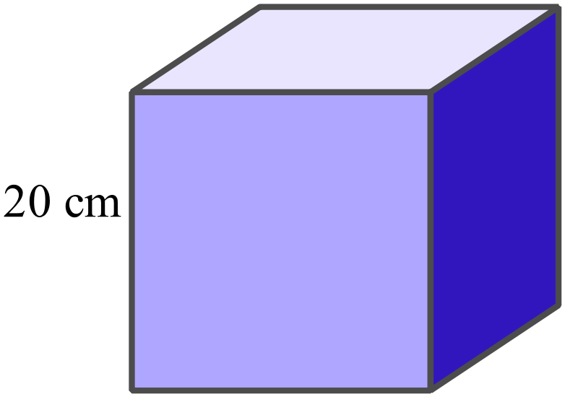What is the volume of the cube shown?

……………………………………………....

………………………………………………

……………………………………………….

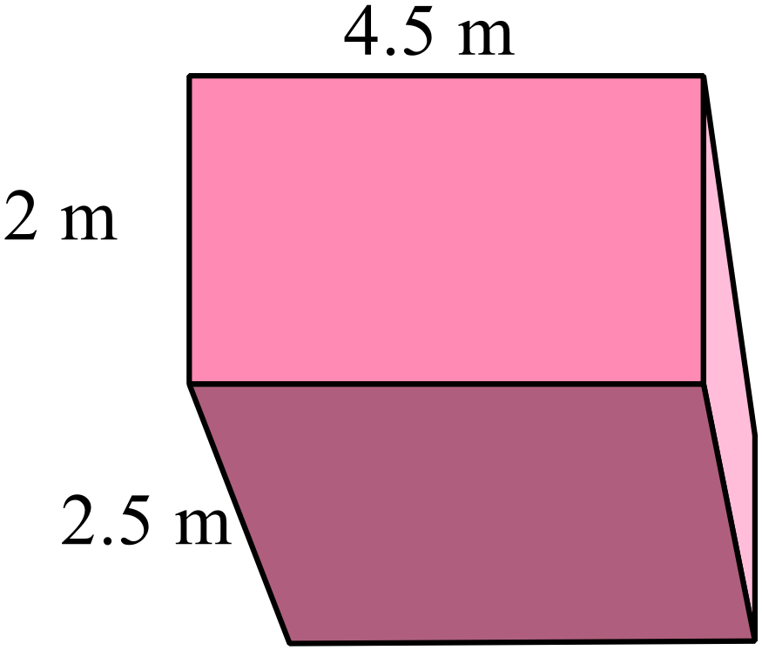What is the volume of this rectangular prism?
………………………………………………

……………………………………………....

………………………………………………

……………………………………………….
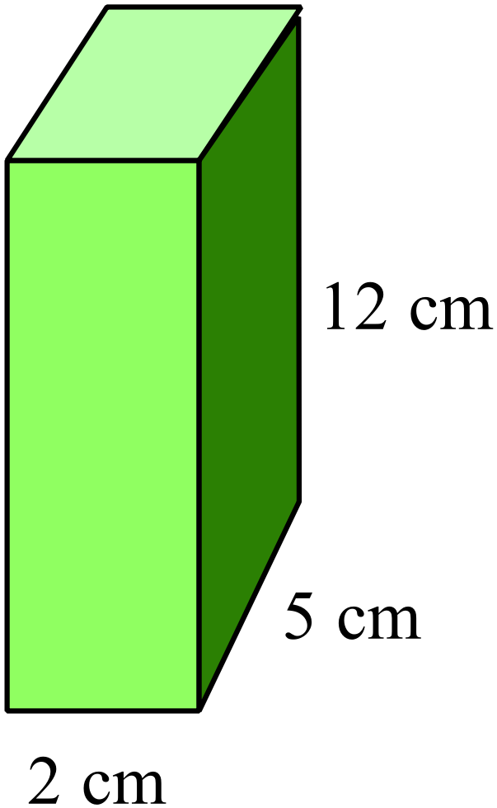Find the surface area of this rectangular prism.

………………………………………………

……………………………………………....

………………………………………………

……………………………………………….
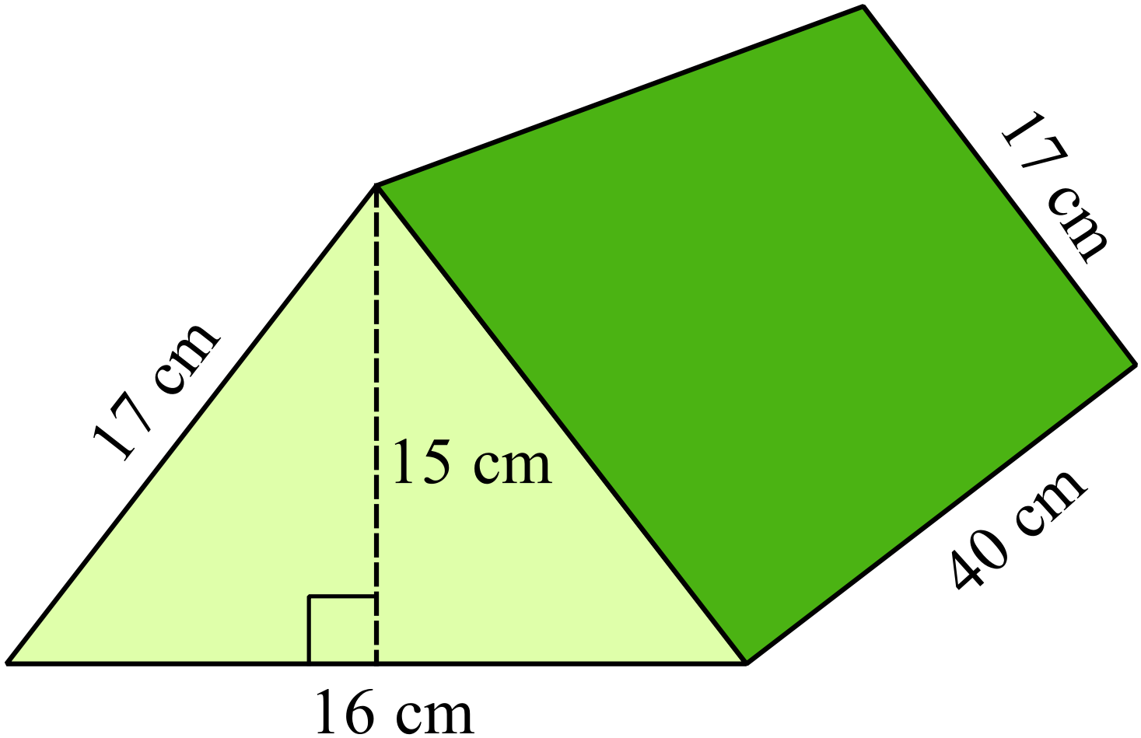What is the volume of this triangular prism?

………………………………………………

……………………………………………....

………………………………………………

……………………………………………….

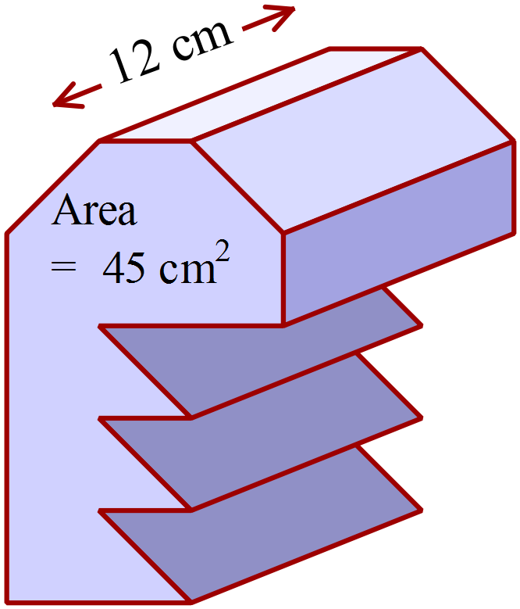The area of the cross section of this prism is 45 cm².
What is the volume of the prism?

………………………………………………

……………………………………………....

………………………………………………

……………………………………………….
A prism has a volume of 2.5 m³.
What is its volume in cubic centimetres?

……………………………………………………………………………………………....

……………………………………………………………………………………………….
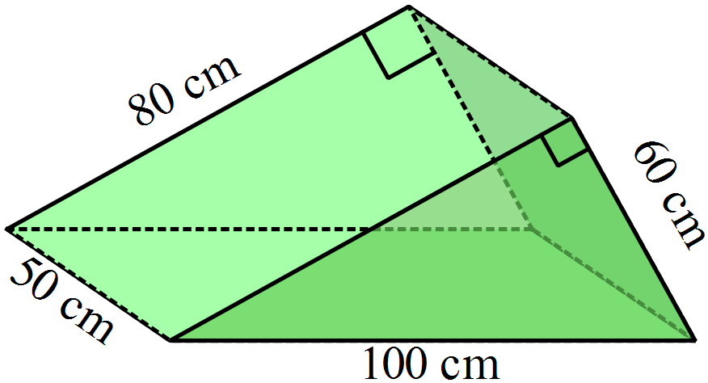Find the surface area of the triangular prism.

………………………………………………

……………………………………………....

………………………………………………

……………………………………………….
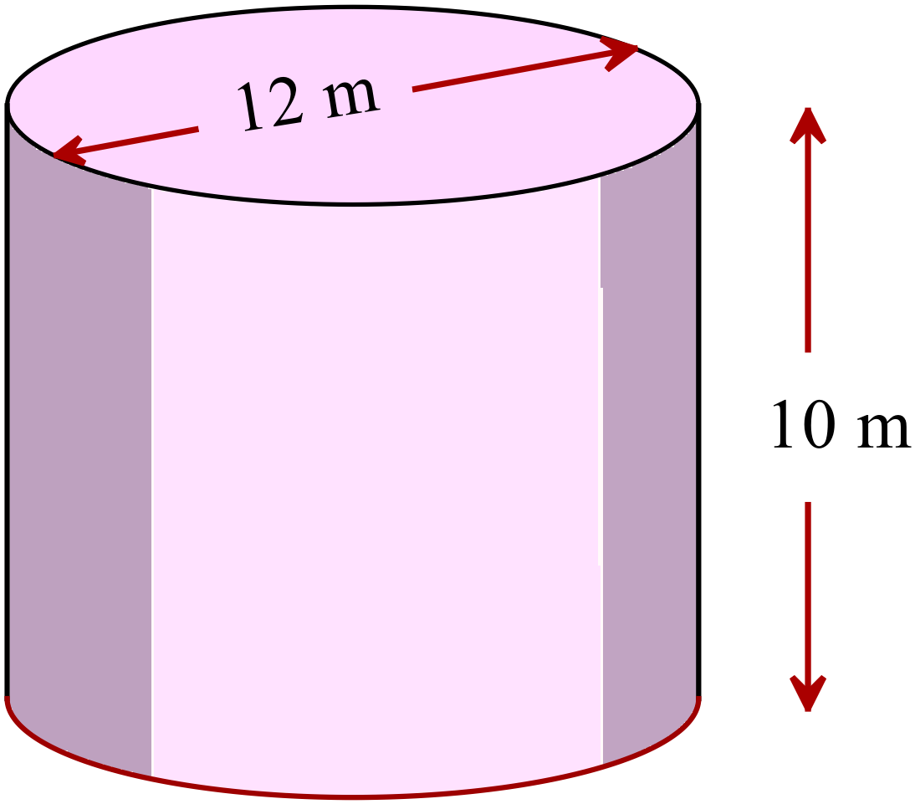What is the volume of the cylinder in terms of 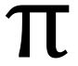 ?

………………………………………………

……………………………………………....

………………………………………………

……………………………………………….
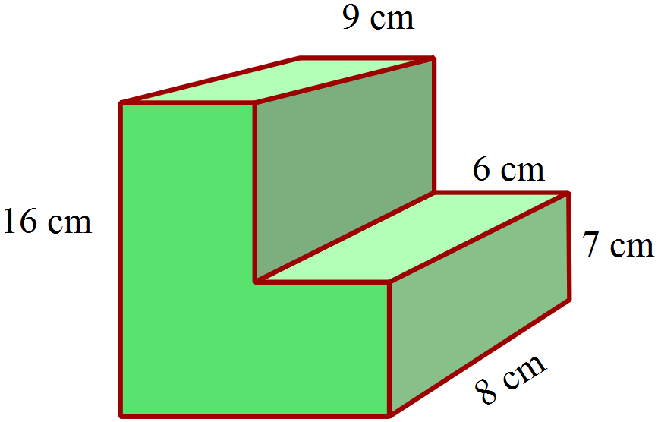What is the volume of the solid shown?

………………………………………………

……………………………………………....

………………………………………………

……………………………………………….
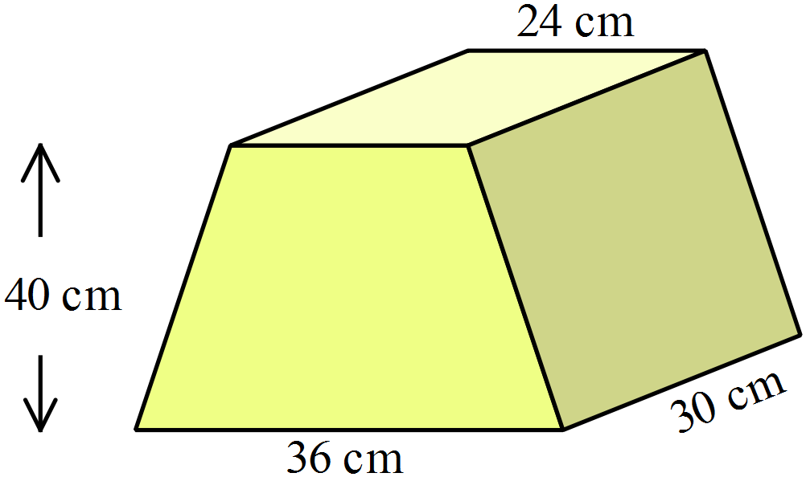The prism shown has a trapezium as its cross section.
What is its volume?
………………………………………………

……………………………………………....

………………………………………………

……………………………………………….
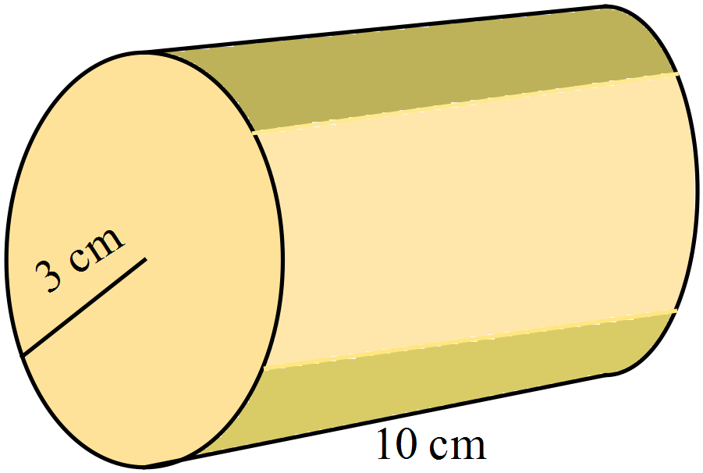Calculate the surface area of the closed cylinder, using 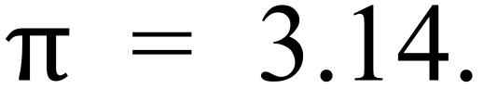
………………………………………………

……………………………………………....

………………………………………………

……………………………………………….

The four timber beams shown all have a cross section measuring 45 mm by 150 mm.
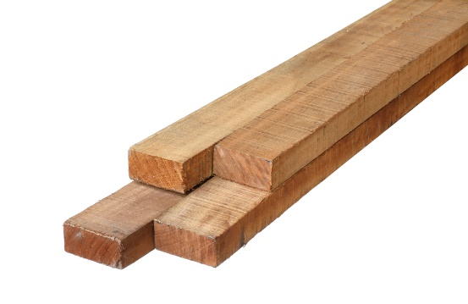
The beams are all 3.6 metres long.
A cubic metre of the timber weighs 480 kg.
What is the weight of the 4 beams?

………………………………………………

……………………………………………....

………………………………………………

……………………………………………….
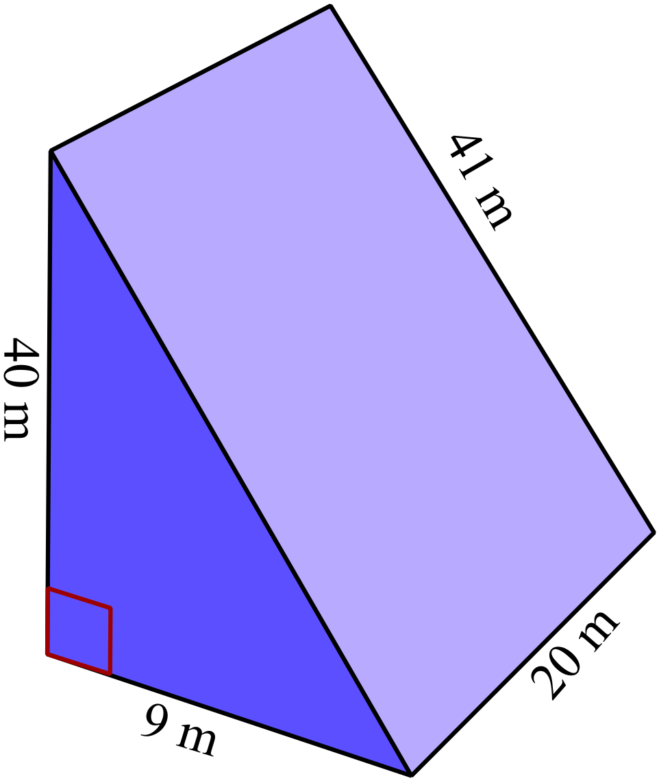The triangular prism shown is to be painted on all its faces, with a paint which covers 40 m² per litre.
How much paint is needed?

………………………………………………

……………………………………………....

………………………………………………

……………………………………………….

The prism shown is a simplified version of a component for an aeroplane.
Its cross section is a kite with diagonals 1.2 m and 2.0 m and it is 0.5 m thick.
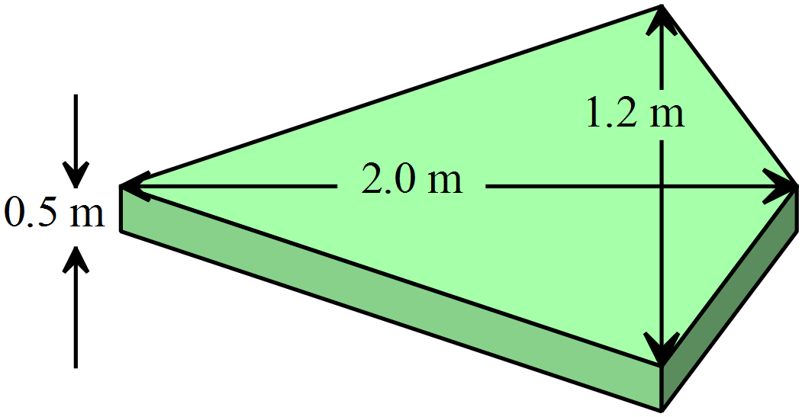A cubic metre of the alloy from which it will be made has a mass of 1200 kg.
What is the mass of the component?

………………………………………………

……………………………………………....

………………………………………………

……………………………………………….

A square prism has dimensions x cm, x cm and 3x cm.
With two slices, it is cut into three identical cubes as shown.
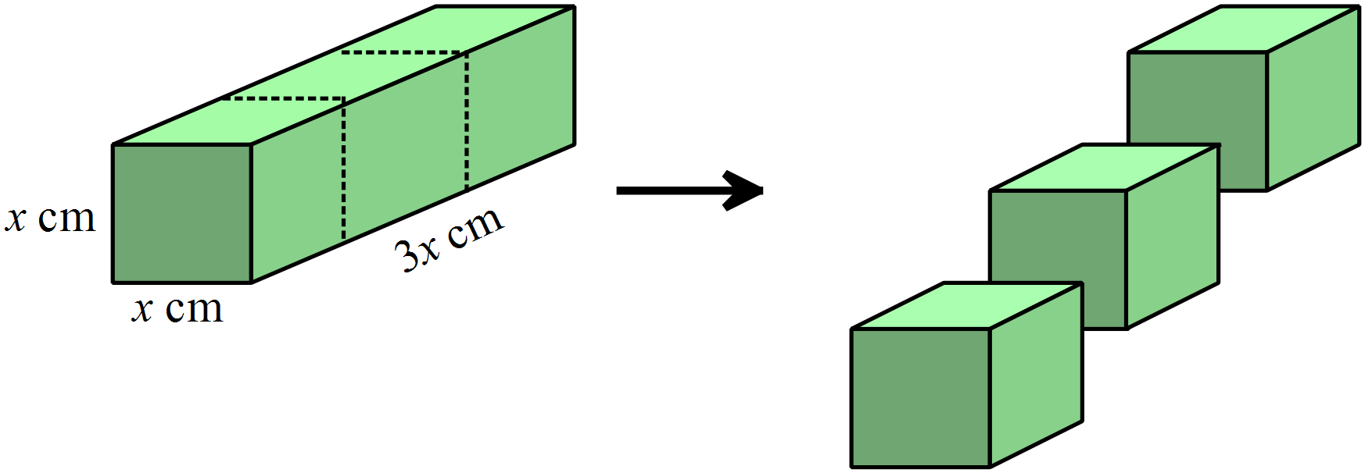

The surface area of the three cubes is greater than that of the original prism.
What is the percentage increase in surface area? (Answer correct to 1 decimal place.)

……………………………………………………………………………………………....

……………………………………………………………………………………………….

……………………………………………………………………………………………....

……………………………………………………………………………………………….

School Name
Mathematics Test 2017
Year 9 |  | Volume and SA of Prisms and Cylinders | Calculator Allowed
 |  | Volume and SA of Prisms and Cylinders | Name_________________
Section 2 Multiple Choice Section
Mark all your answers on the accompanying multiple choice answer sheet, not on this test paper. You may do any working out on this test paper. Calculators are allowed for this section.

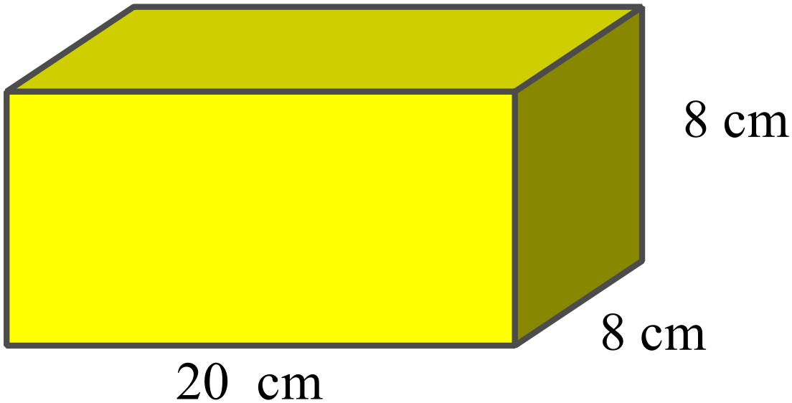What is the volume of this square prism?

A. 320 cm²
B. 480 cm²
C. 640 cm²
D. 1280 cm²
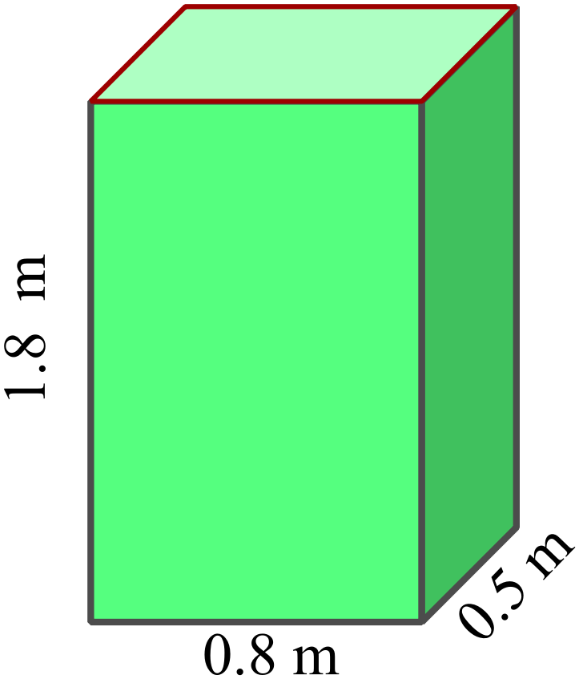What is the surface area of this rectangular prism?

A. 0.72 m²
B. 2.74 m²
C. 5.48 m²
D. 8.64 m²

Calculate the surface area of this cube, correct to the nearest square centimetre.
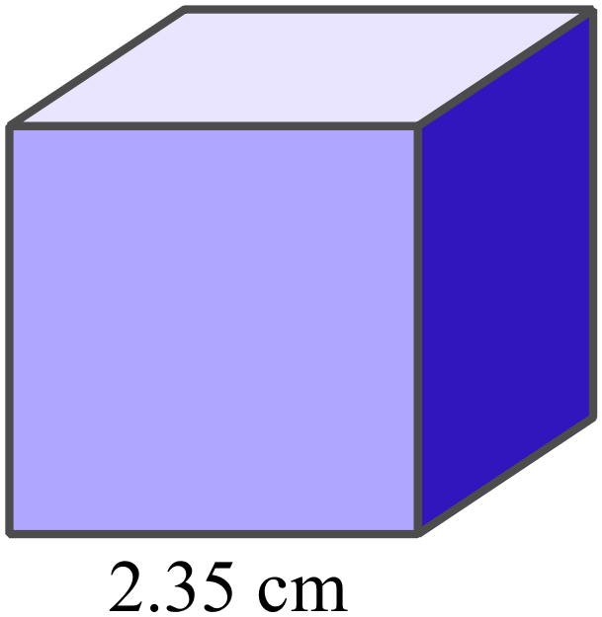
A. 33 cm²
B. 34 cm²
C. 35 cm²
D. 38 cm²

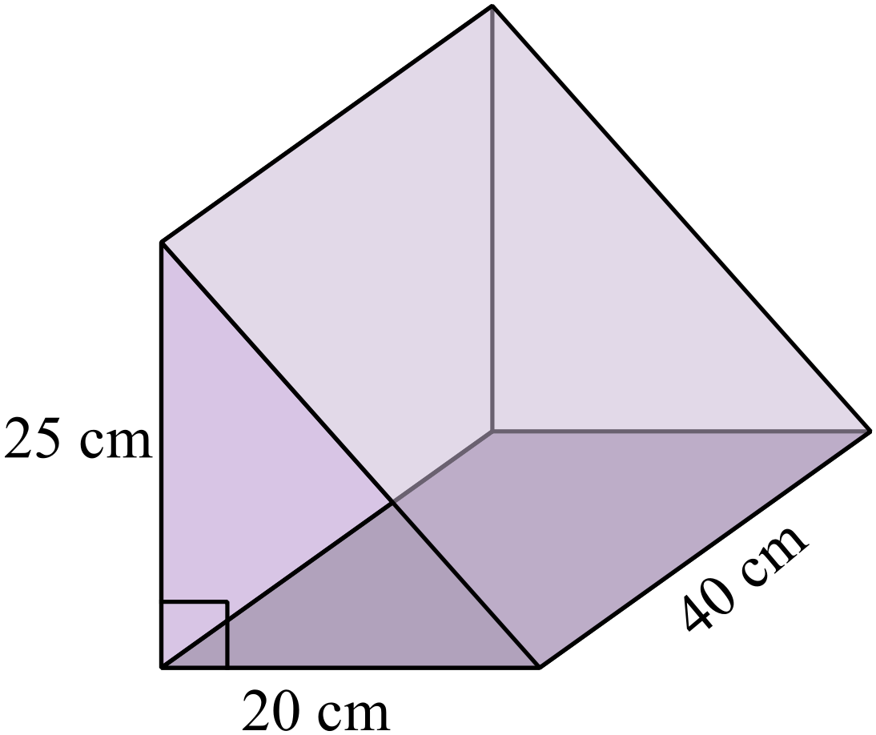What is the volume of this triangular prism?

A. 5 000 cm³
B. 7 500 cm³
C. 10 000 cm³
D. 20 000 cm³

This rectangular prism has a volume of 3000 m².
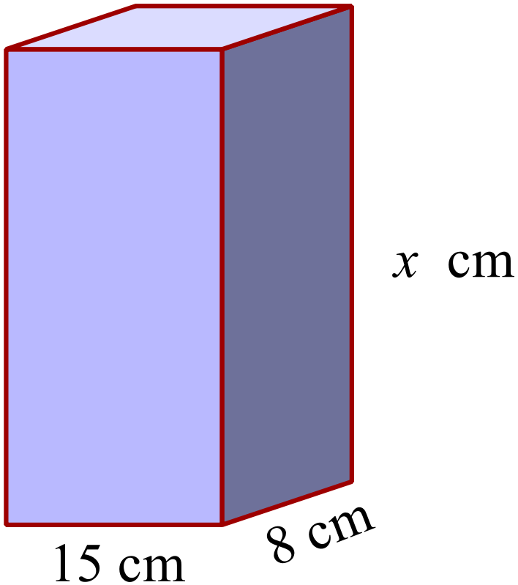What is its height (x cm)?

A. 20 cm
B. 25 cm
C. 30 cm
D. 50 cm

A cube has a surface area of 13.5 cm².
What is its side length?
A. 1.25 cm B. 1.5 cm C. 2.25 cm D. 2.5 cm
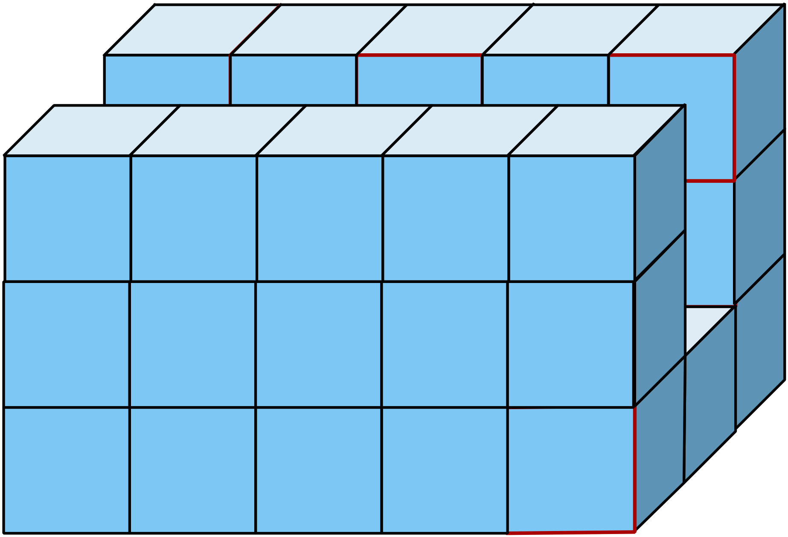This prism is made by joining 1 centimetre cubes together.
What is the volume of the prism?

A. 22 cm³
B. 35 cm³
C. 40 cm³
D. 45 cm³

The cross section of this prism is a rhombus.
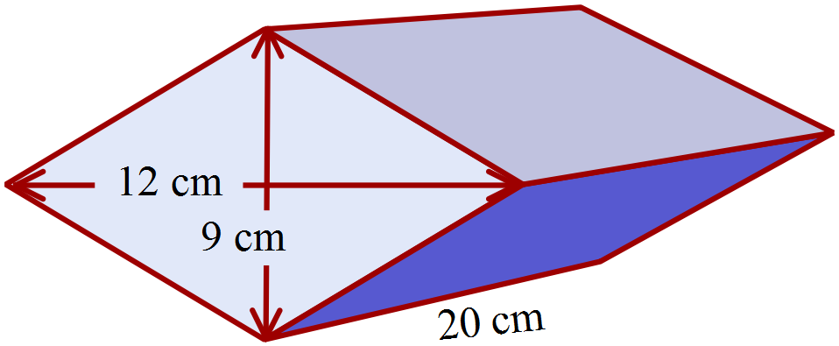What is its volume?

A. 1080 cm³
B. 1416 cm³
C. 1620 cm³
D. 2160 cm³
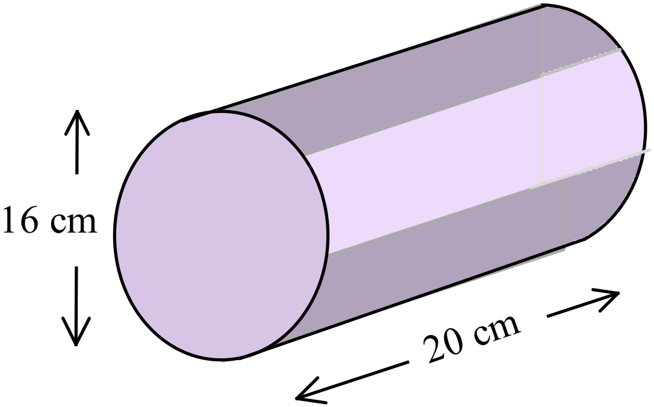Find the volume of the cylinder shown.

A. 1005 cm³
B. 1508 cm³
C. 2011 cm³
D. 4021 cm³
Find the surface area of the triangular prism whose net is shown.
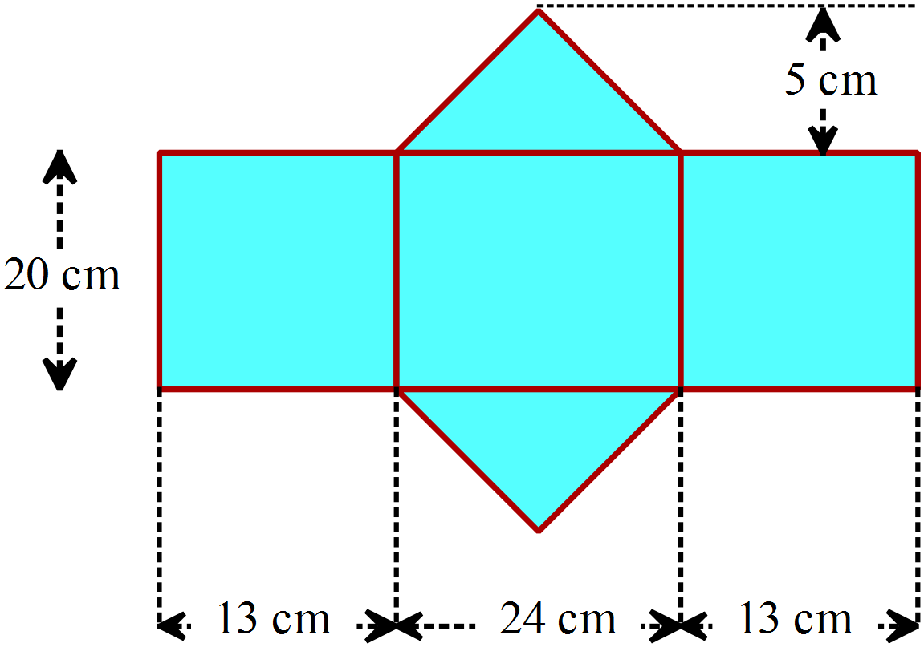

A. 940 cm²
B. 1060 cm²
C. 1120 cm²
D. 1200 cm²

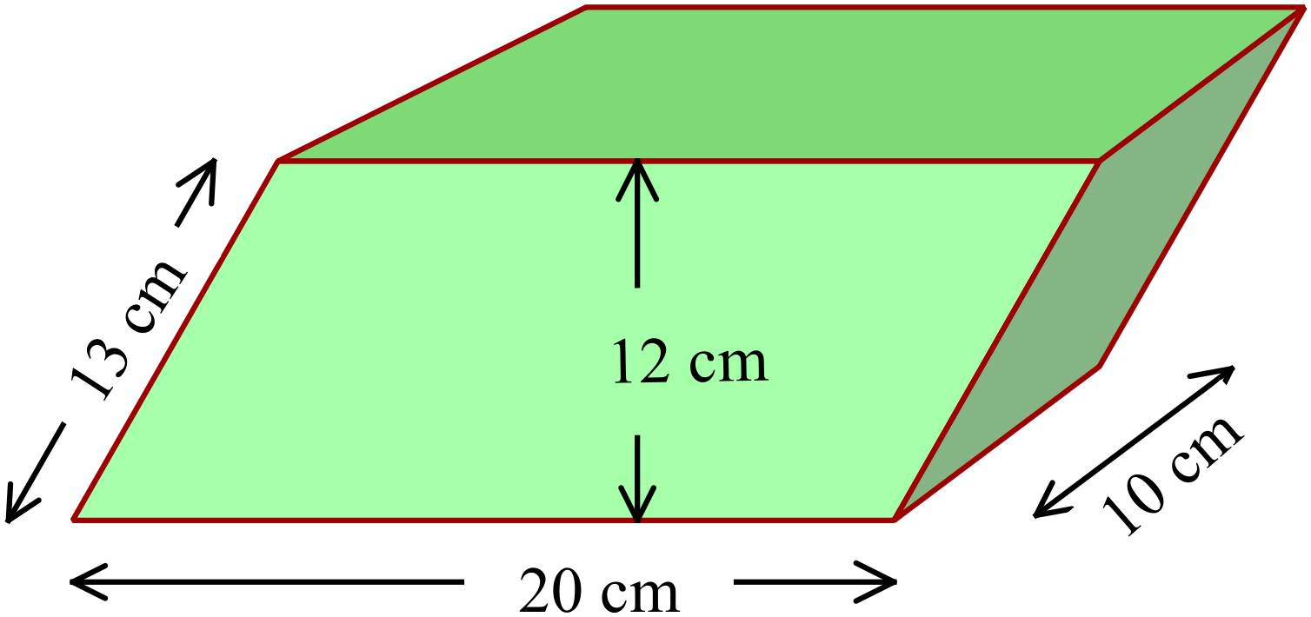This prism has a parallelogram as its cross section.
What is its surface area?

A. 880 cm²
B. 940 cm²
C. 1010 cm²
D. 1140 cm²
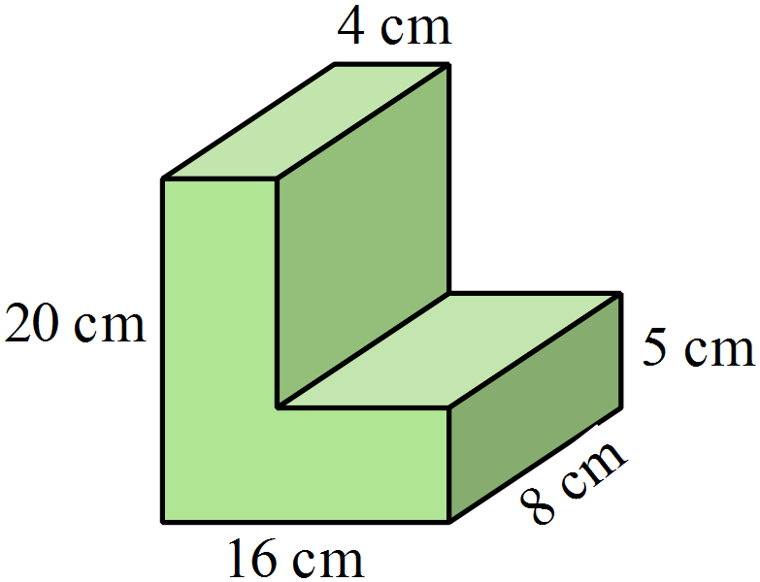Calculate the volume of the prism shown.

A. 1120 cm³
B. 1200 cm³
C. 1440 cm³
D. 2400 cm³

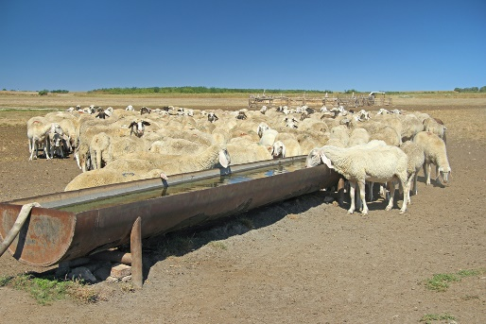
A water trough for sheep is in the shape of half a cylinder with diameter 40 cm and length 4.2 metres.
What volume of water will the trough hold?
A. 0.13 m³
B. 0.26 m³
C. 0.52 m³
D. 1.06 m³
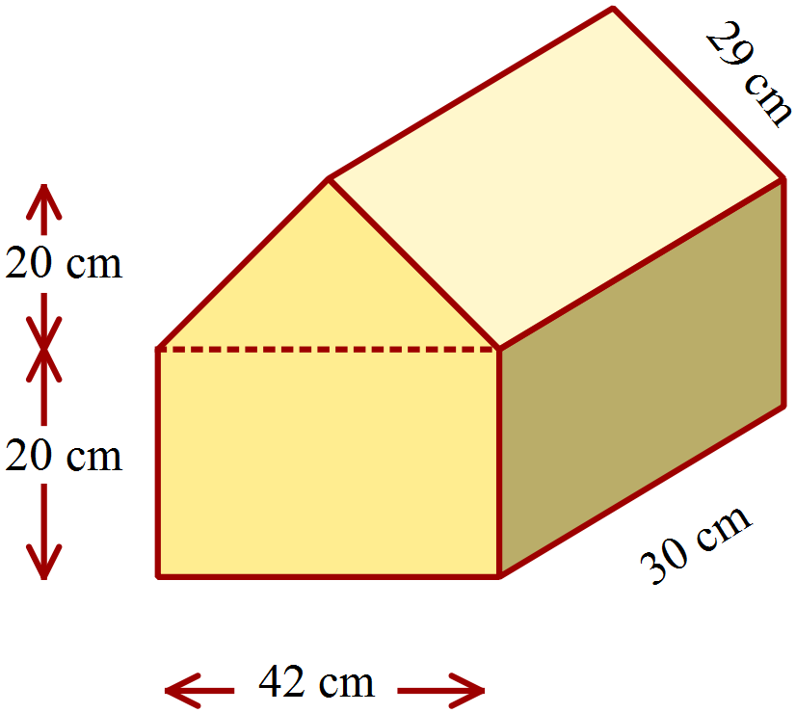Calculate the surface area of the prism shown.

A. 6720 cm²
B. 7200 cm²
C. 8040 cm²
D. 8880 cm²

Find the cross section of this prism is made up of a semicircle and a triangle.
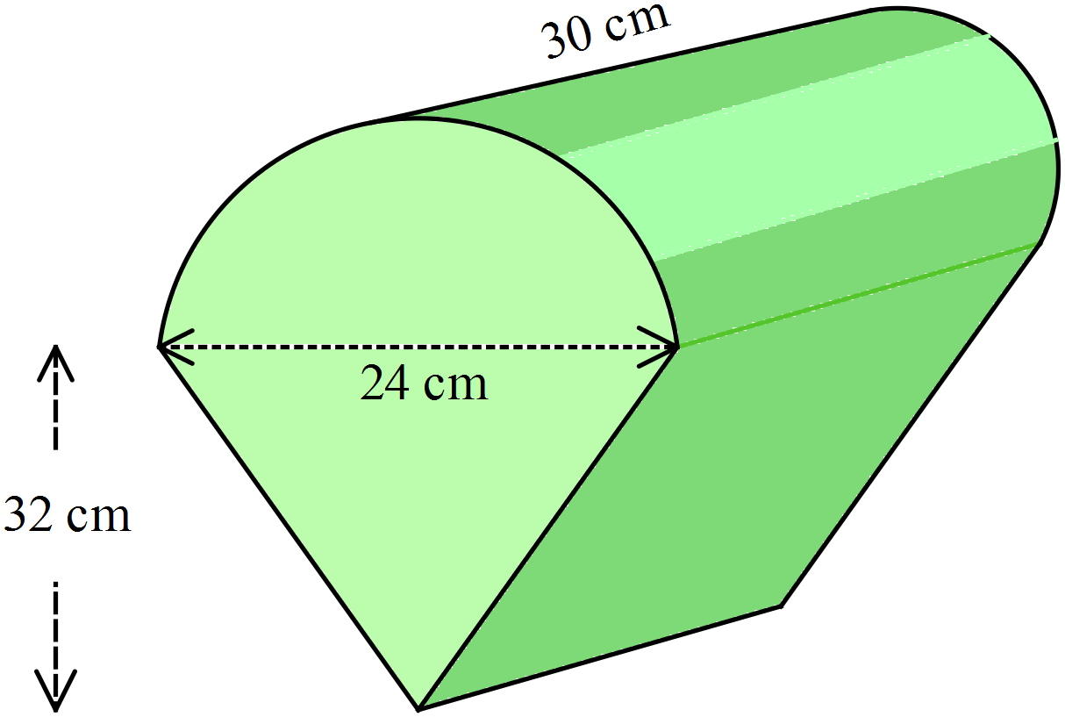Find the volume of the prism.

A. 9048 cm³
B. 16 405 cm³
C. 18 306 cm³
D. 19 526 cm³

School Name
Mathematics 2017
Multiple Choice Answer Sheet
Volume and SA of Prisms and Cylinders
Name _____________________________________________
Completely fill the response oval representing the most correct answer.
1. A B C D
2. A B C D
3. A B C D
4. A B C D
5. A B C D
6. A B C D
7. A B C D
8. A B C D
9. A B C D
10. A B C D
11. A B C D
12. A B C D
13. A B C D
14. A B C D
15. A B C D

School Name
Mathematics Test 2017
Year 9 | Volume and SA of Prisms and Cylinders | Non Calculator Section
ANSWERS

Question | Working and Answer
 | 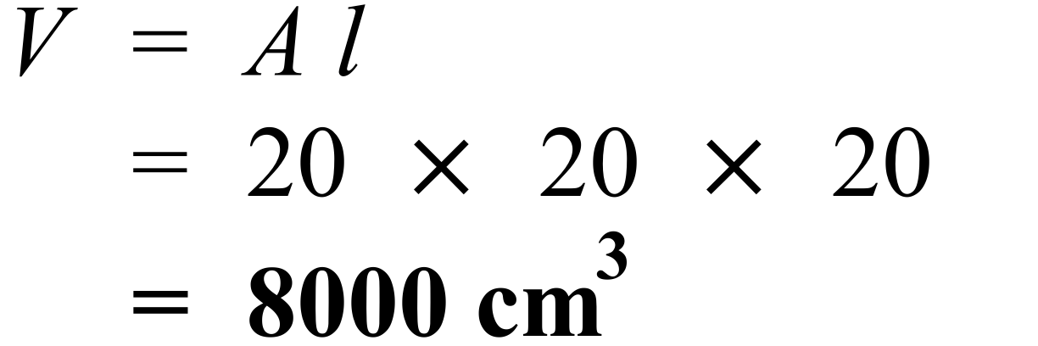
 | 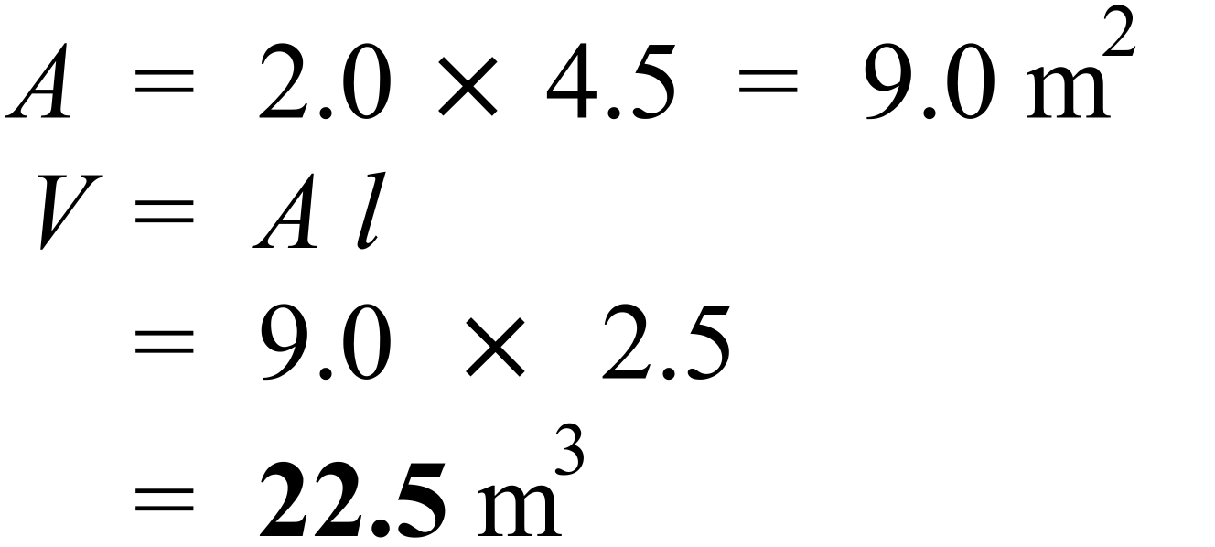
 | 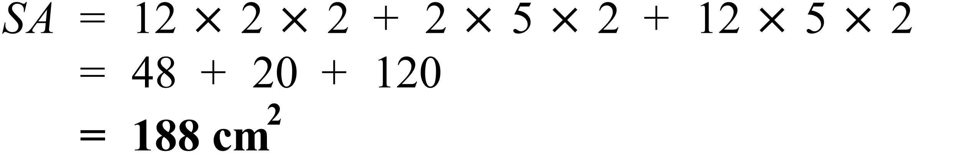
 | 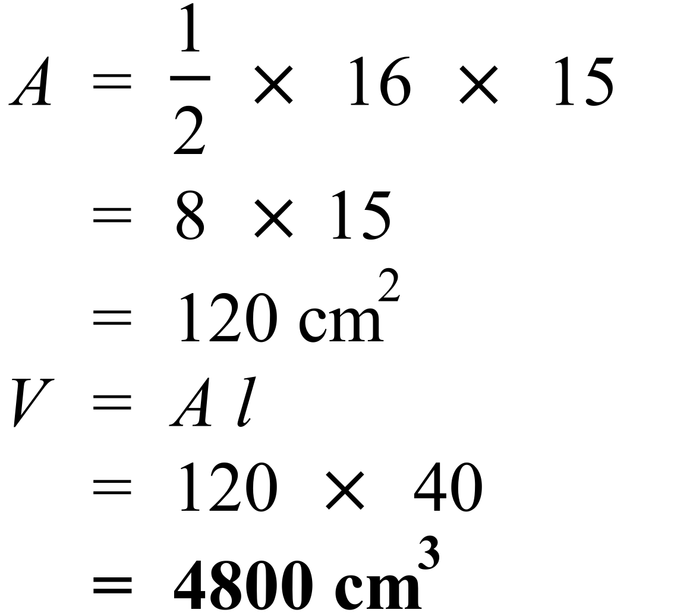
 | 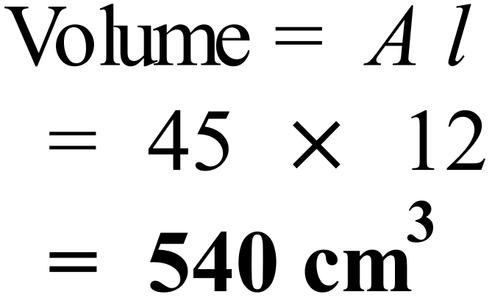
 | 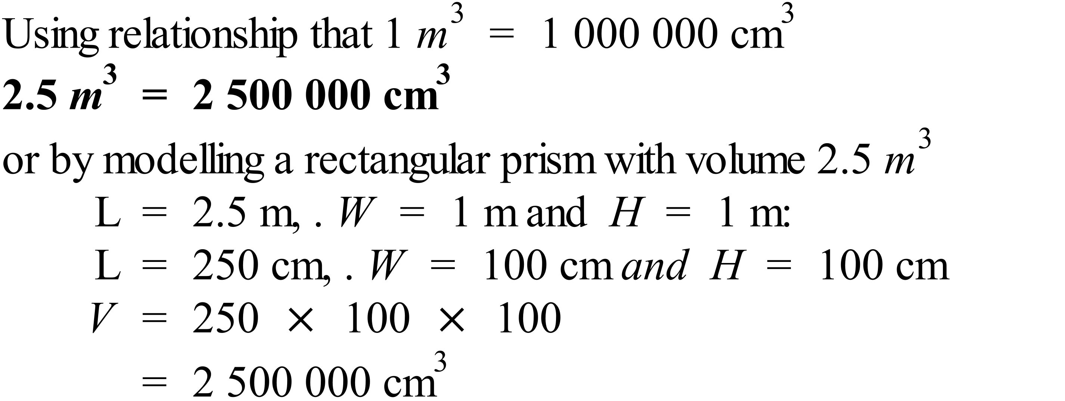
 | 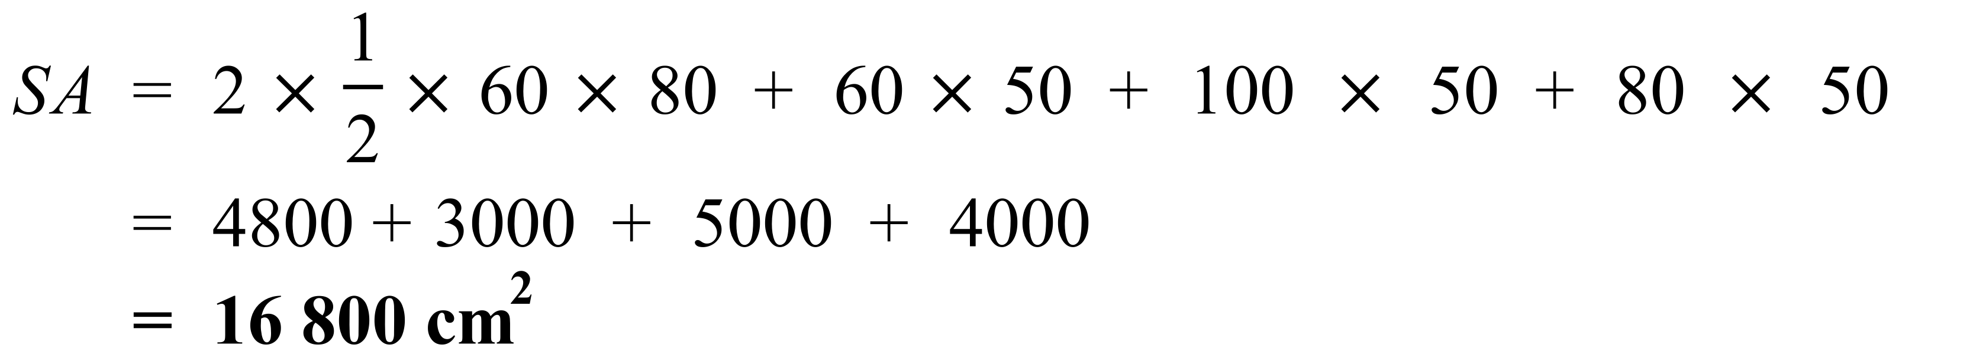
 | 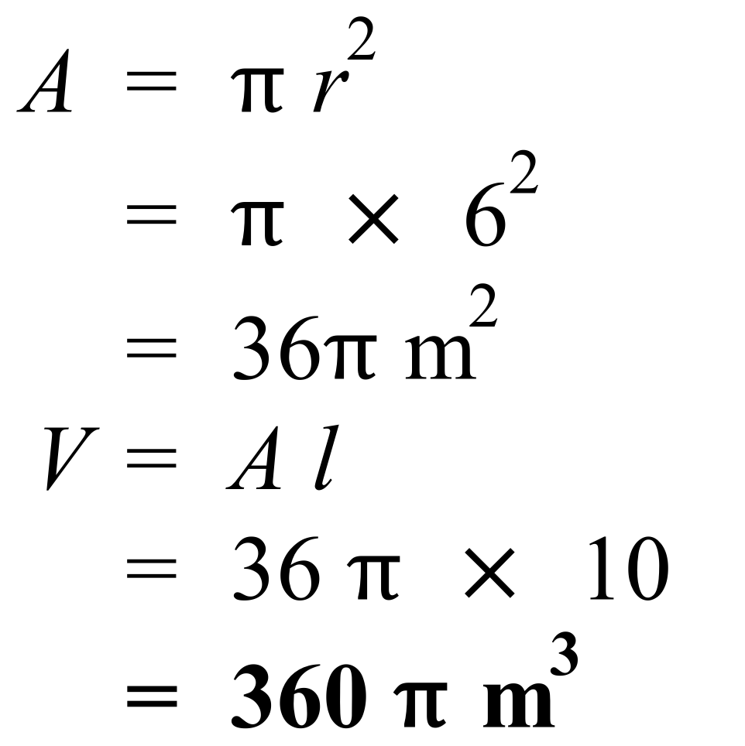
 | 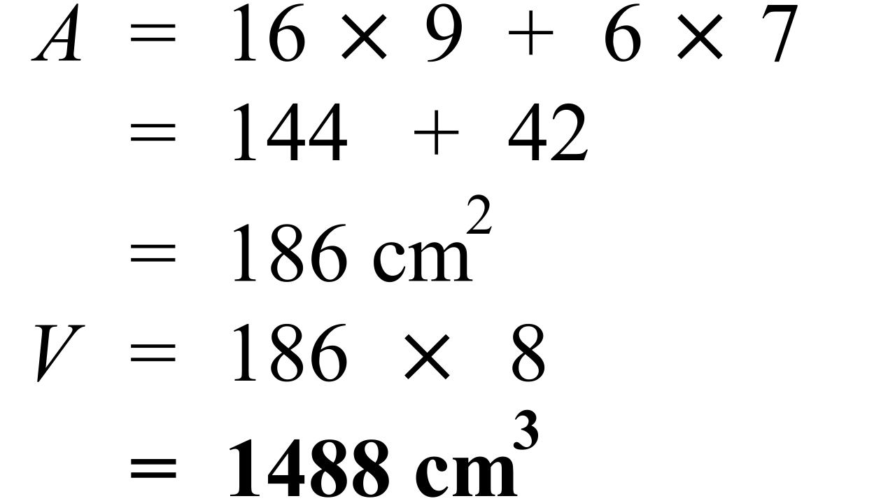
 | 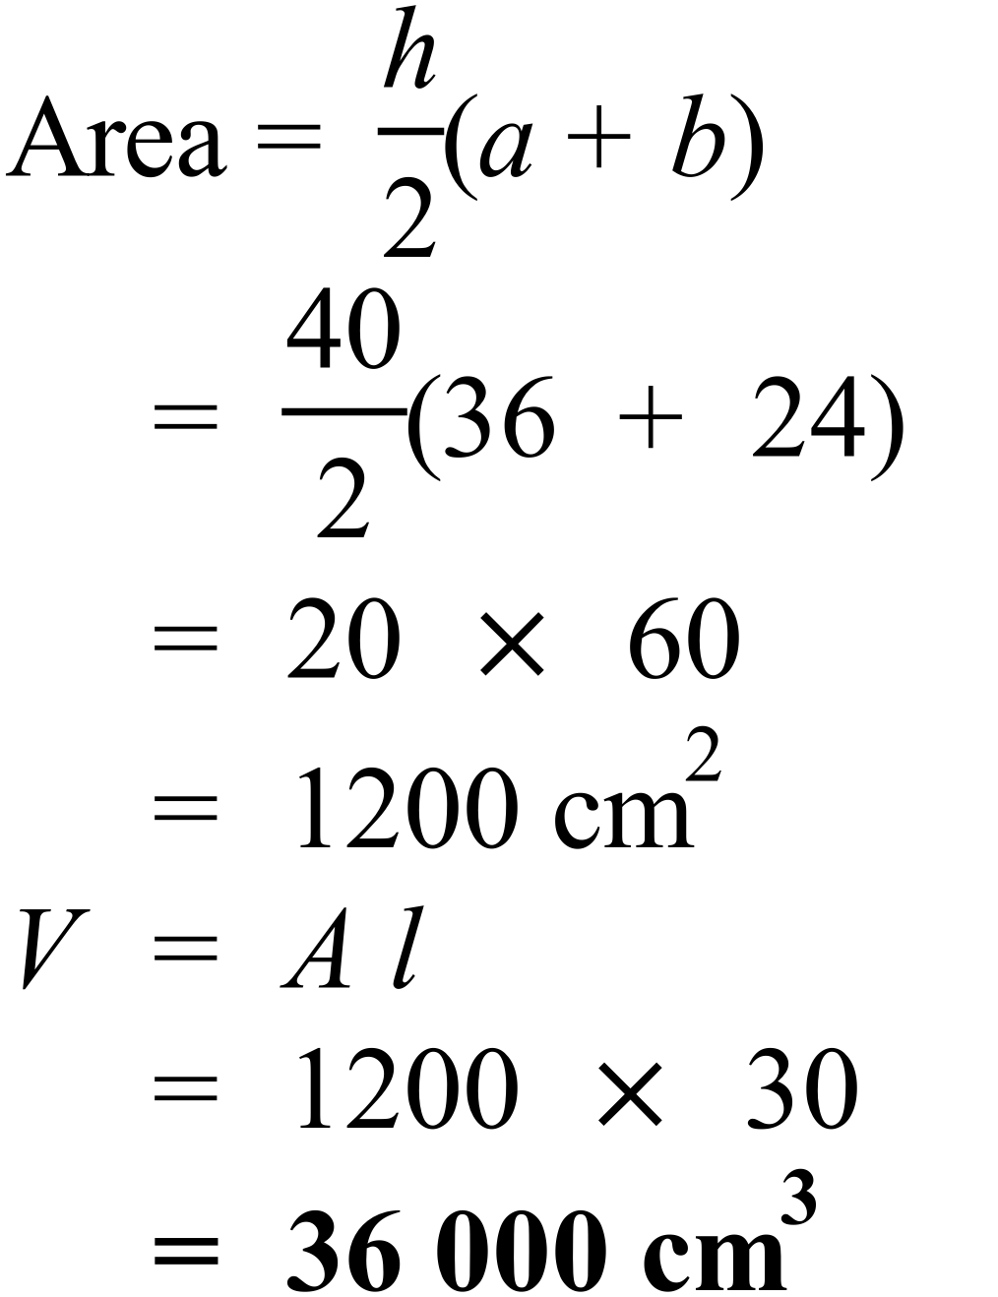
 | 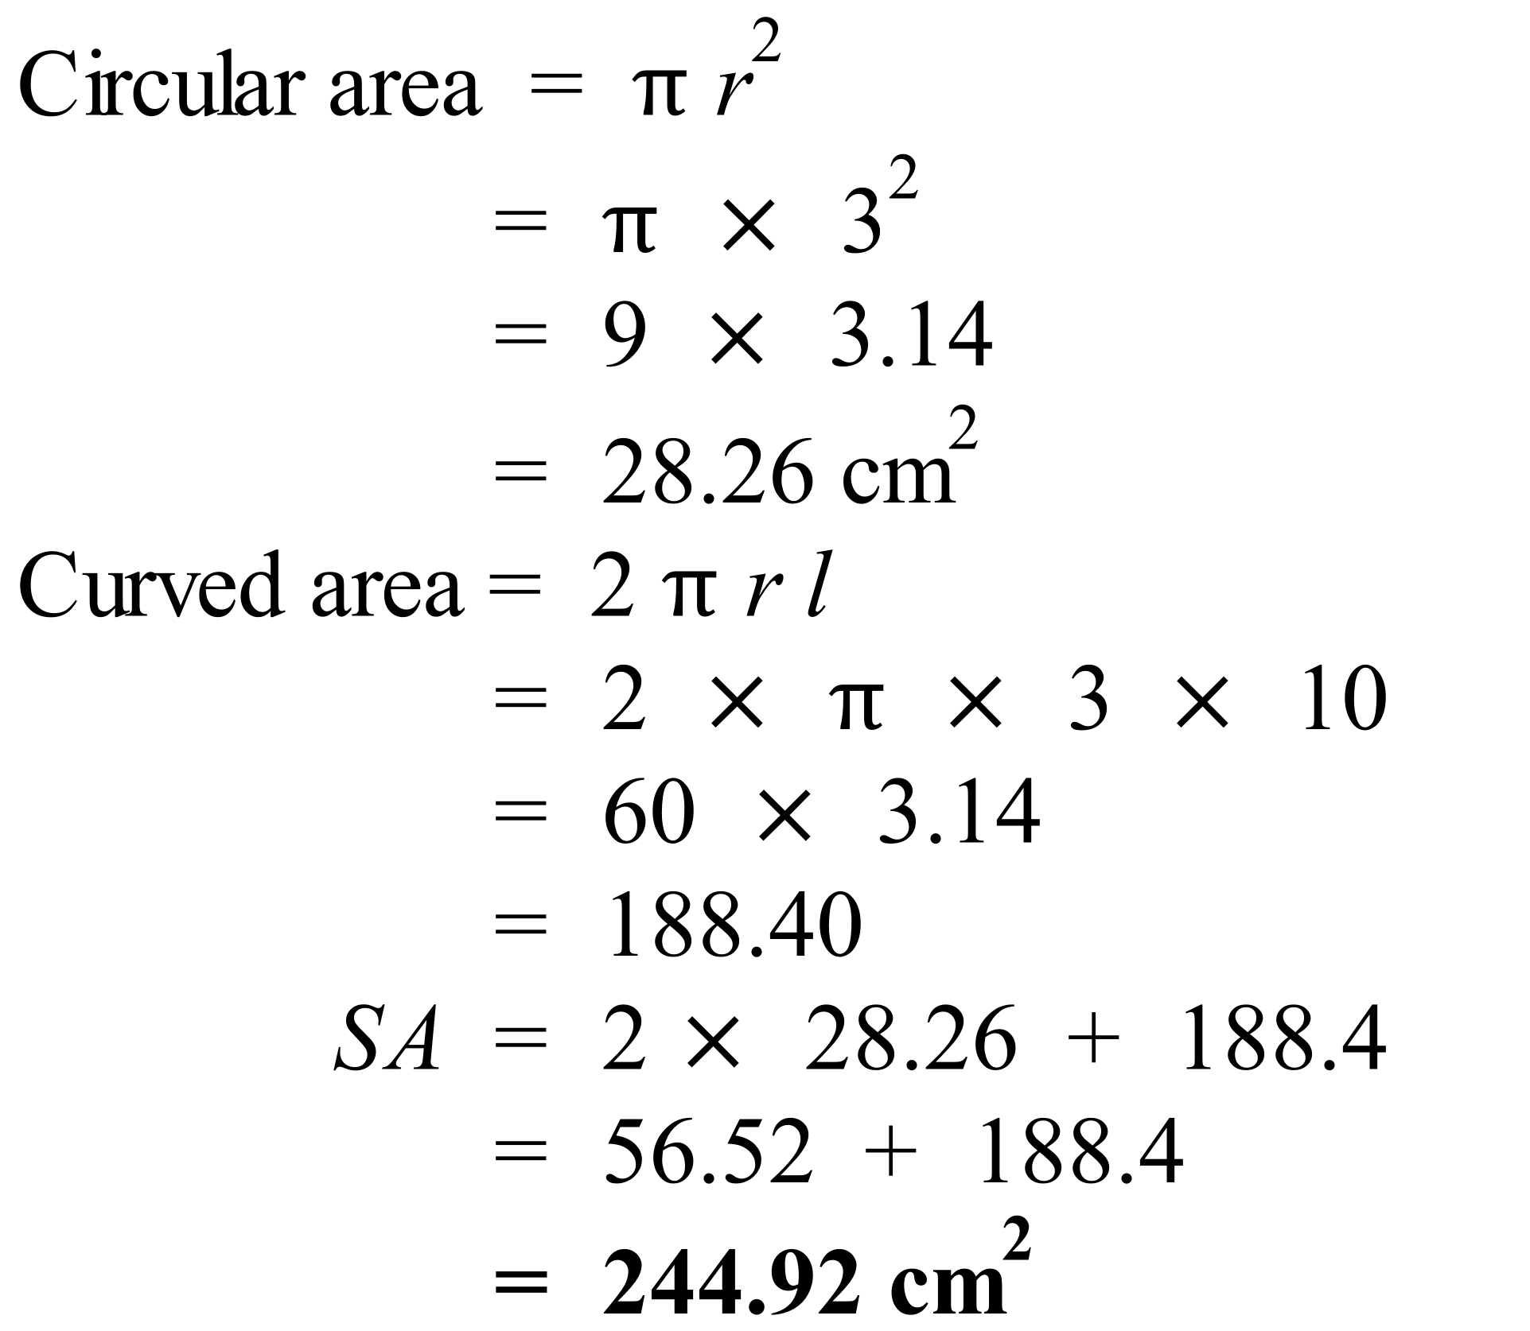
 | 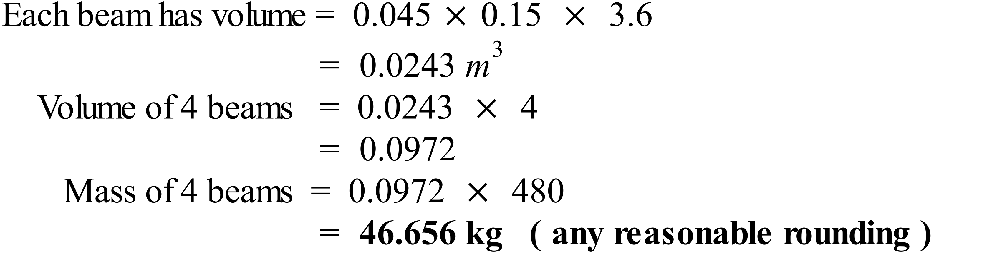
 | 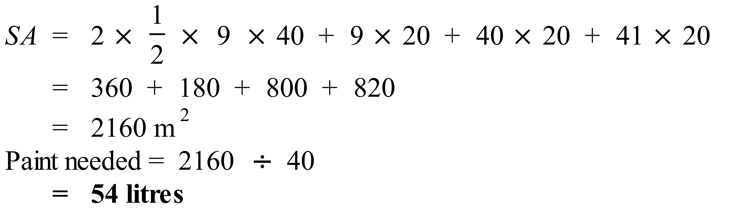
 | 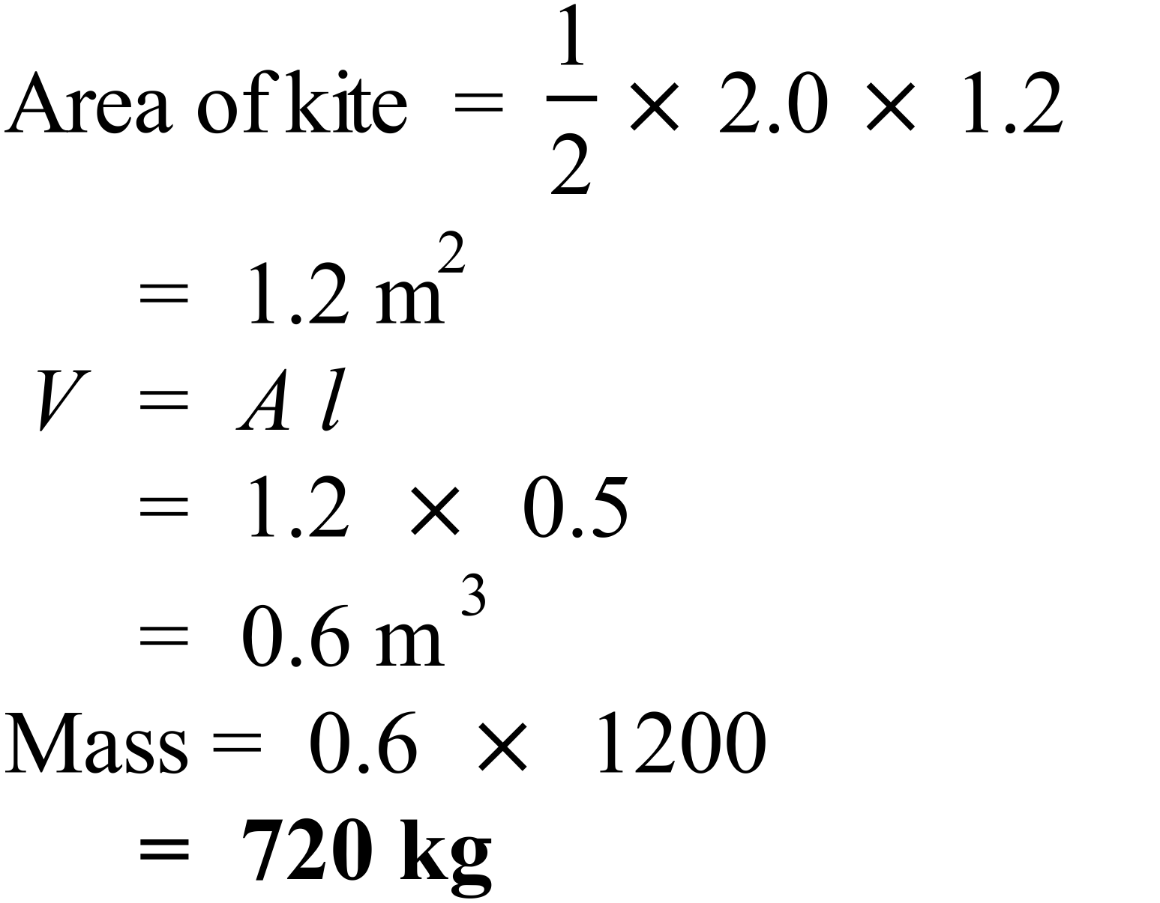
 | 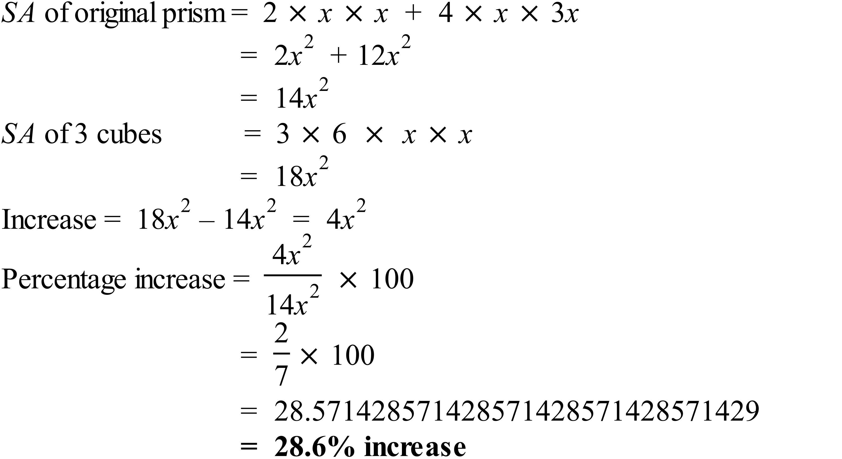

School Name
Mathematics Test 2017
Year 9 | Volume and SA of Prisms and Cylinders | Calculator Allowed  Multiple Choice  Section

ANSWERS

Question | Working | M C Answer
 | 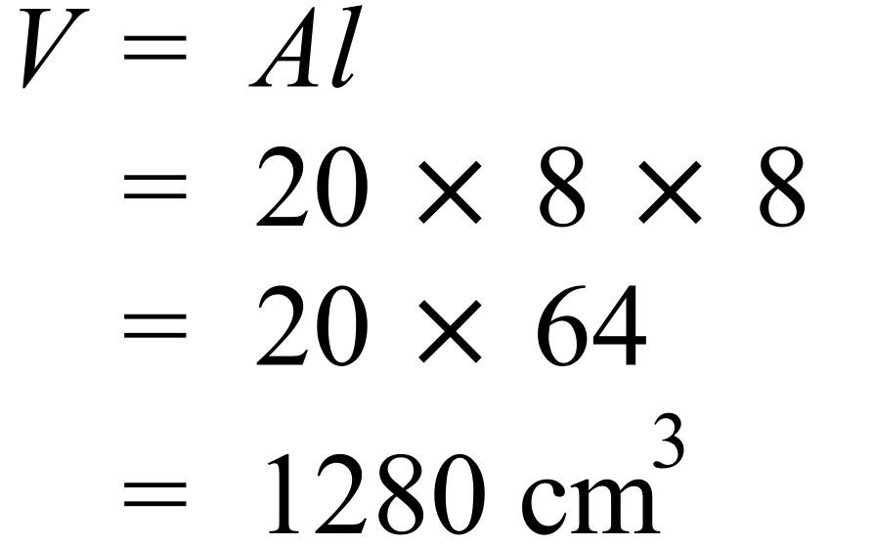 | D
 | 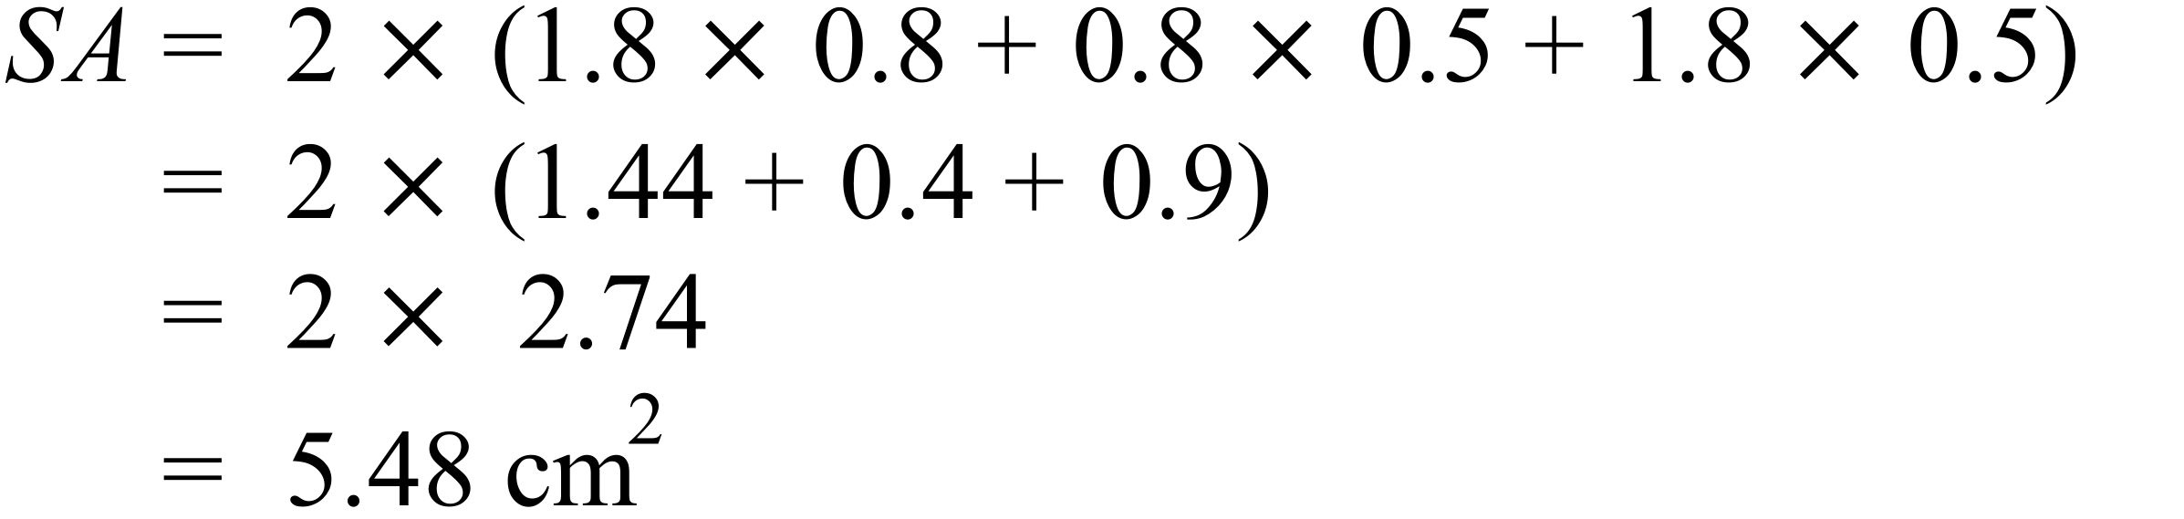 | C
 | 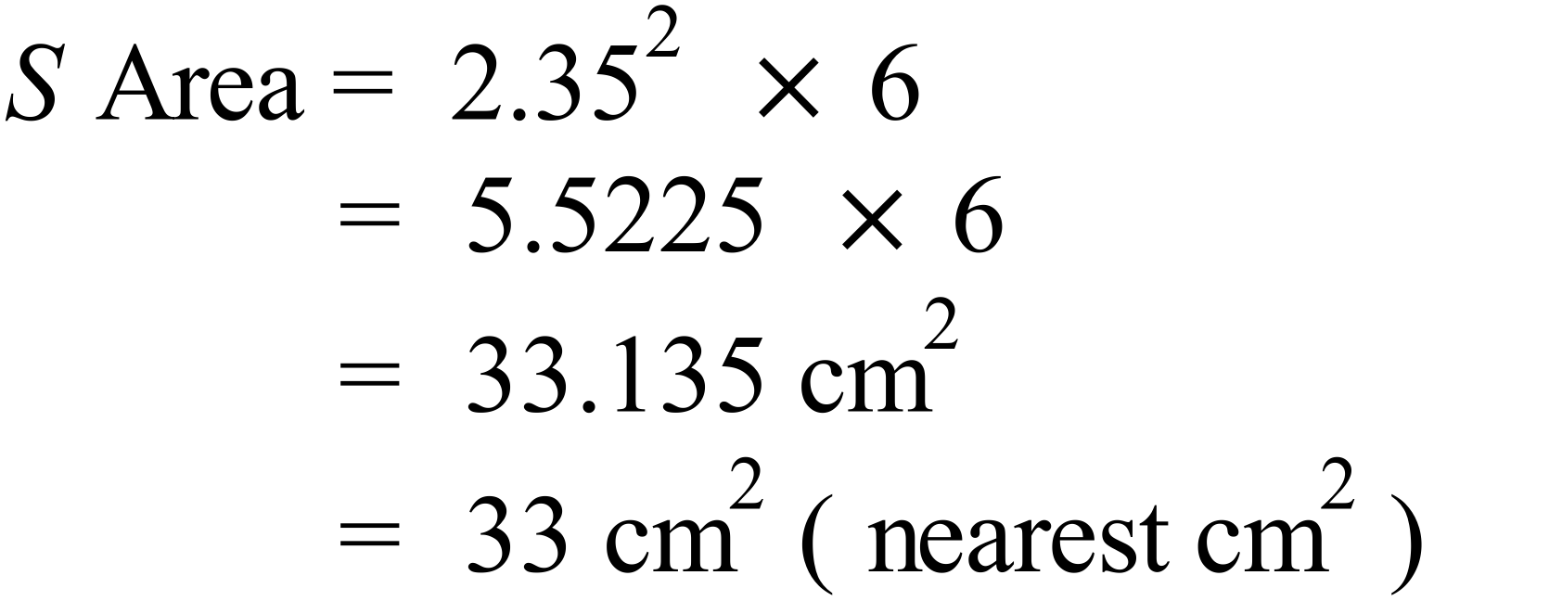 | A
 | 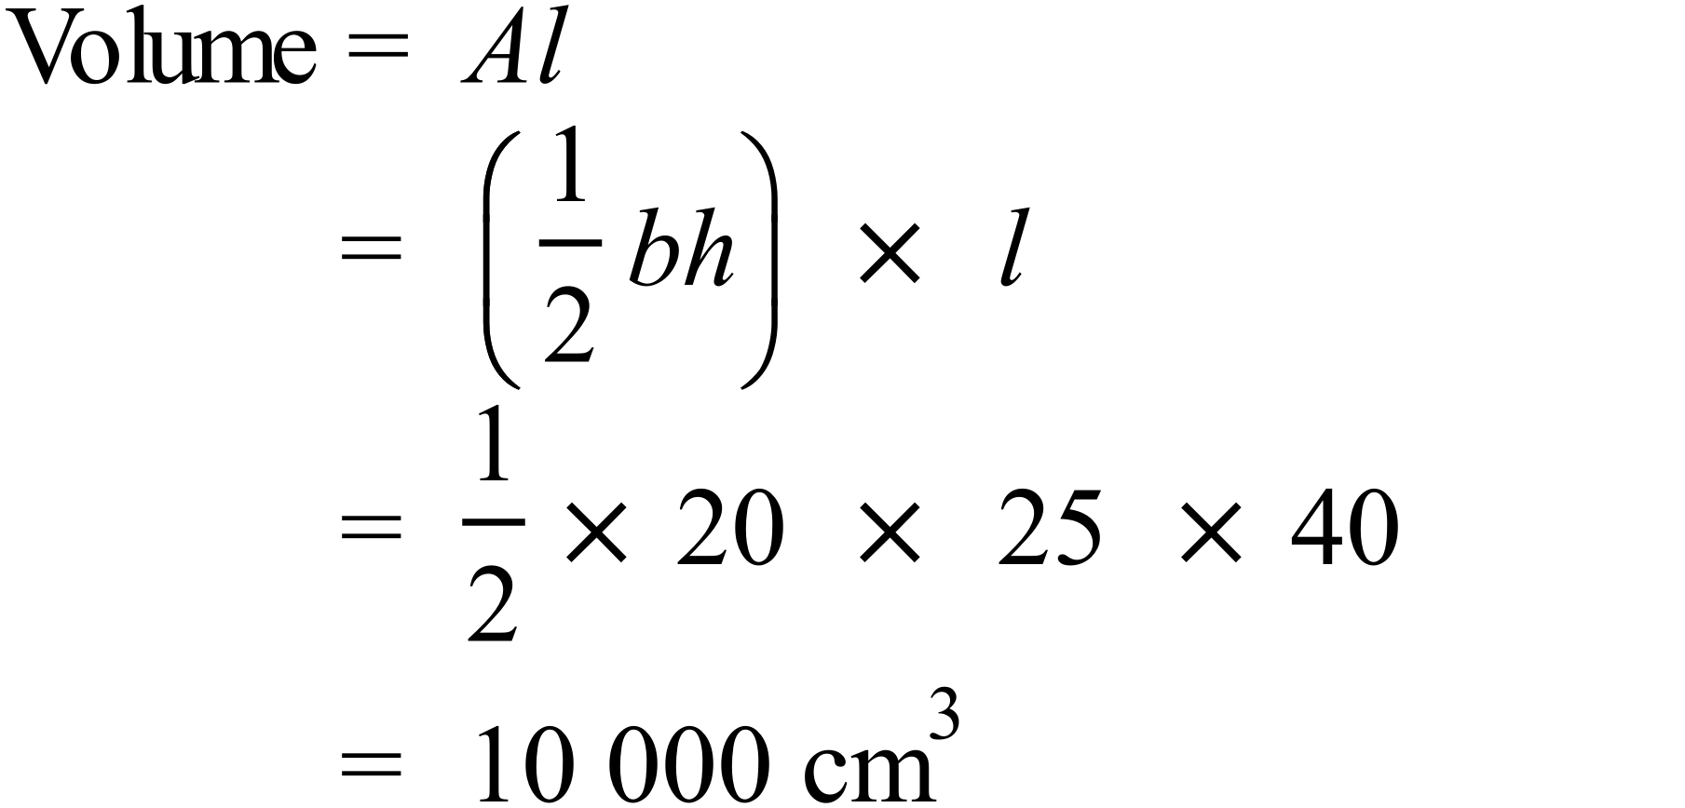 | C
 | 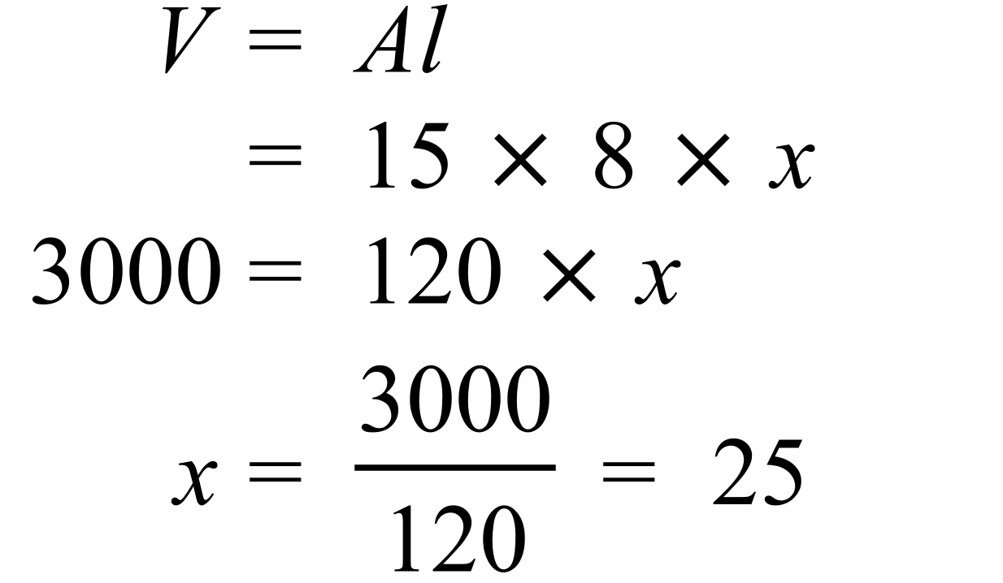 | B
 | 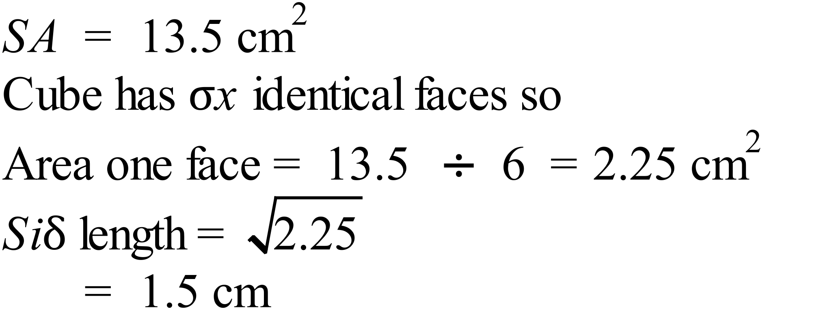 | B
 | 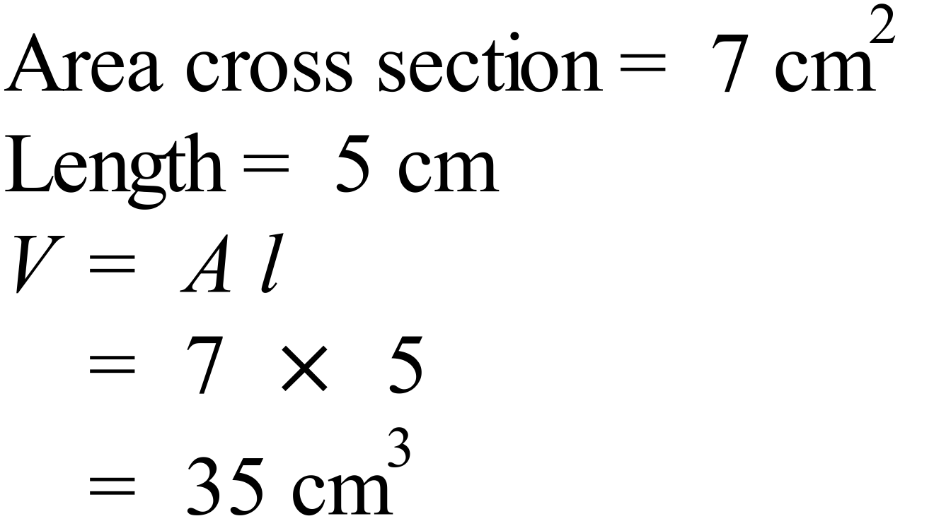 | B
 | 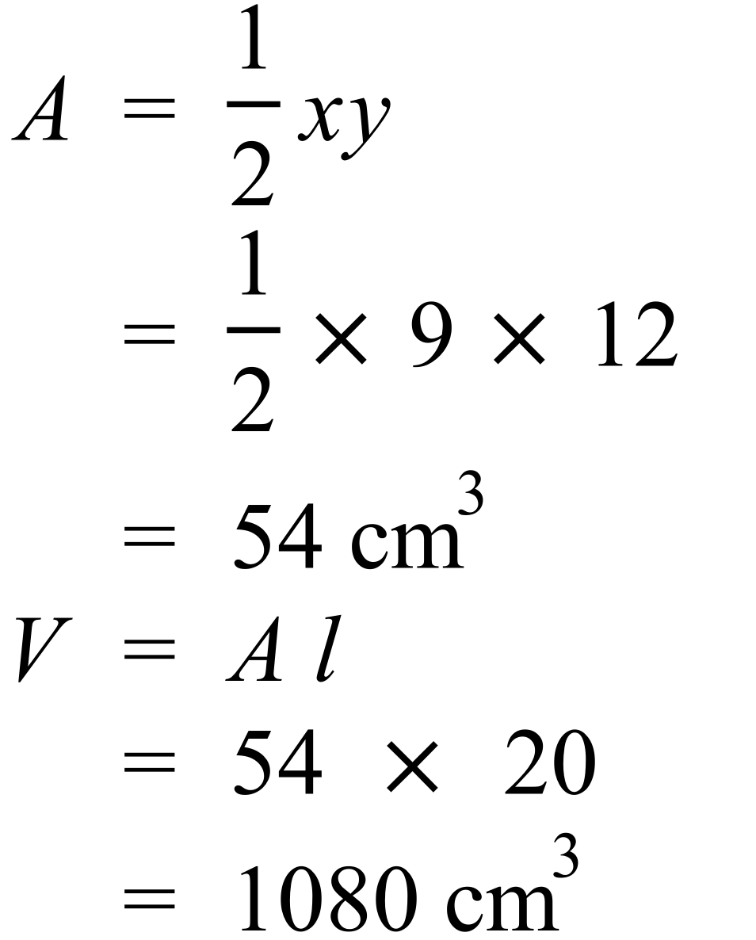 | A
 | 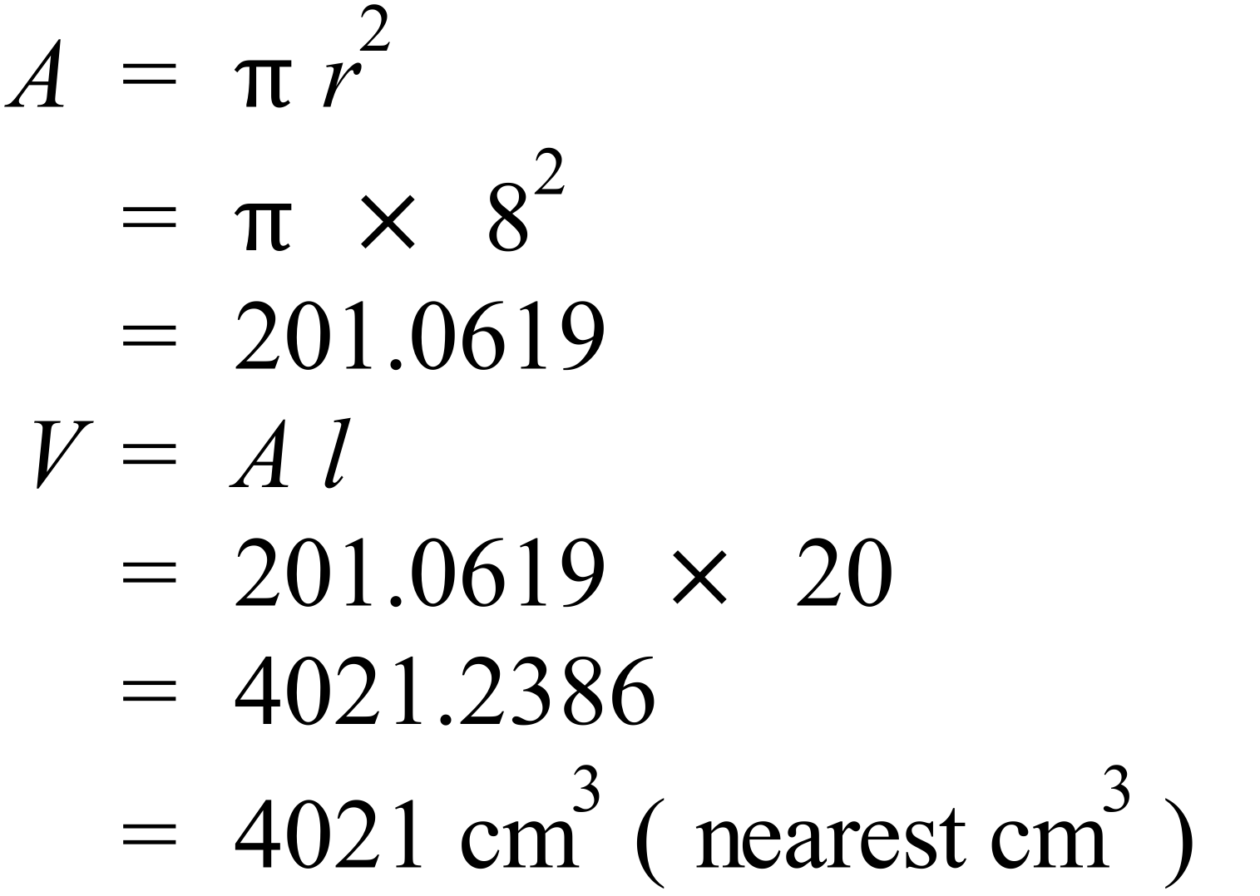 | D
 | 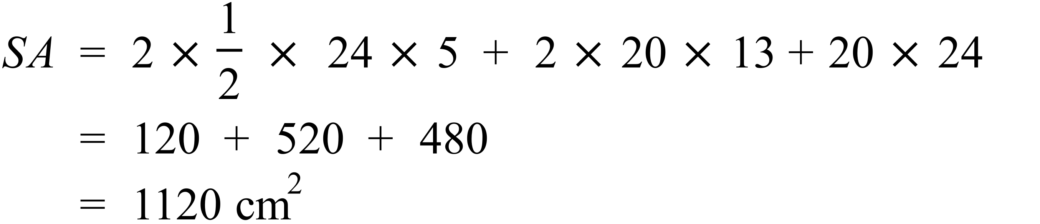 | C
 | 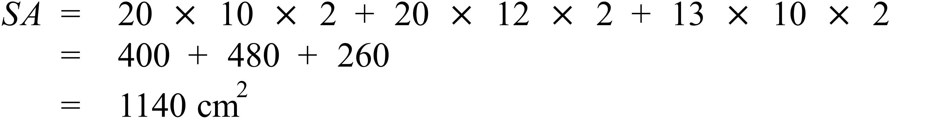 | D
 | 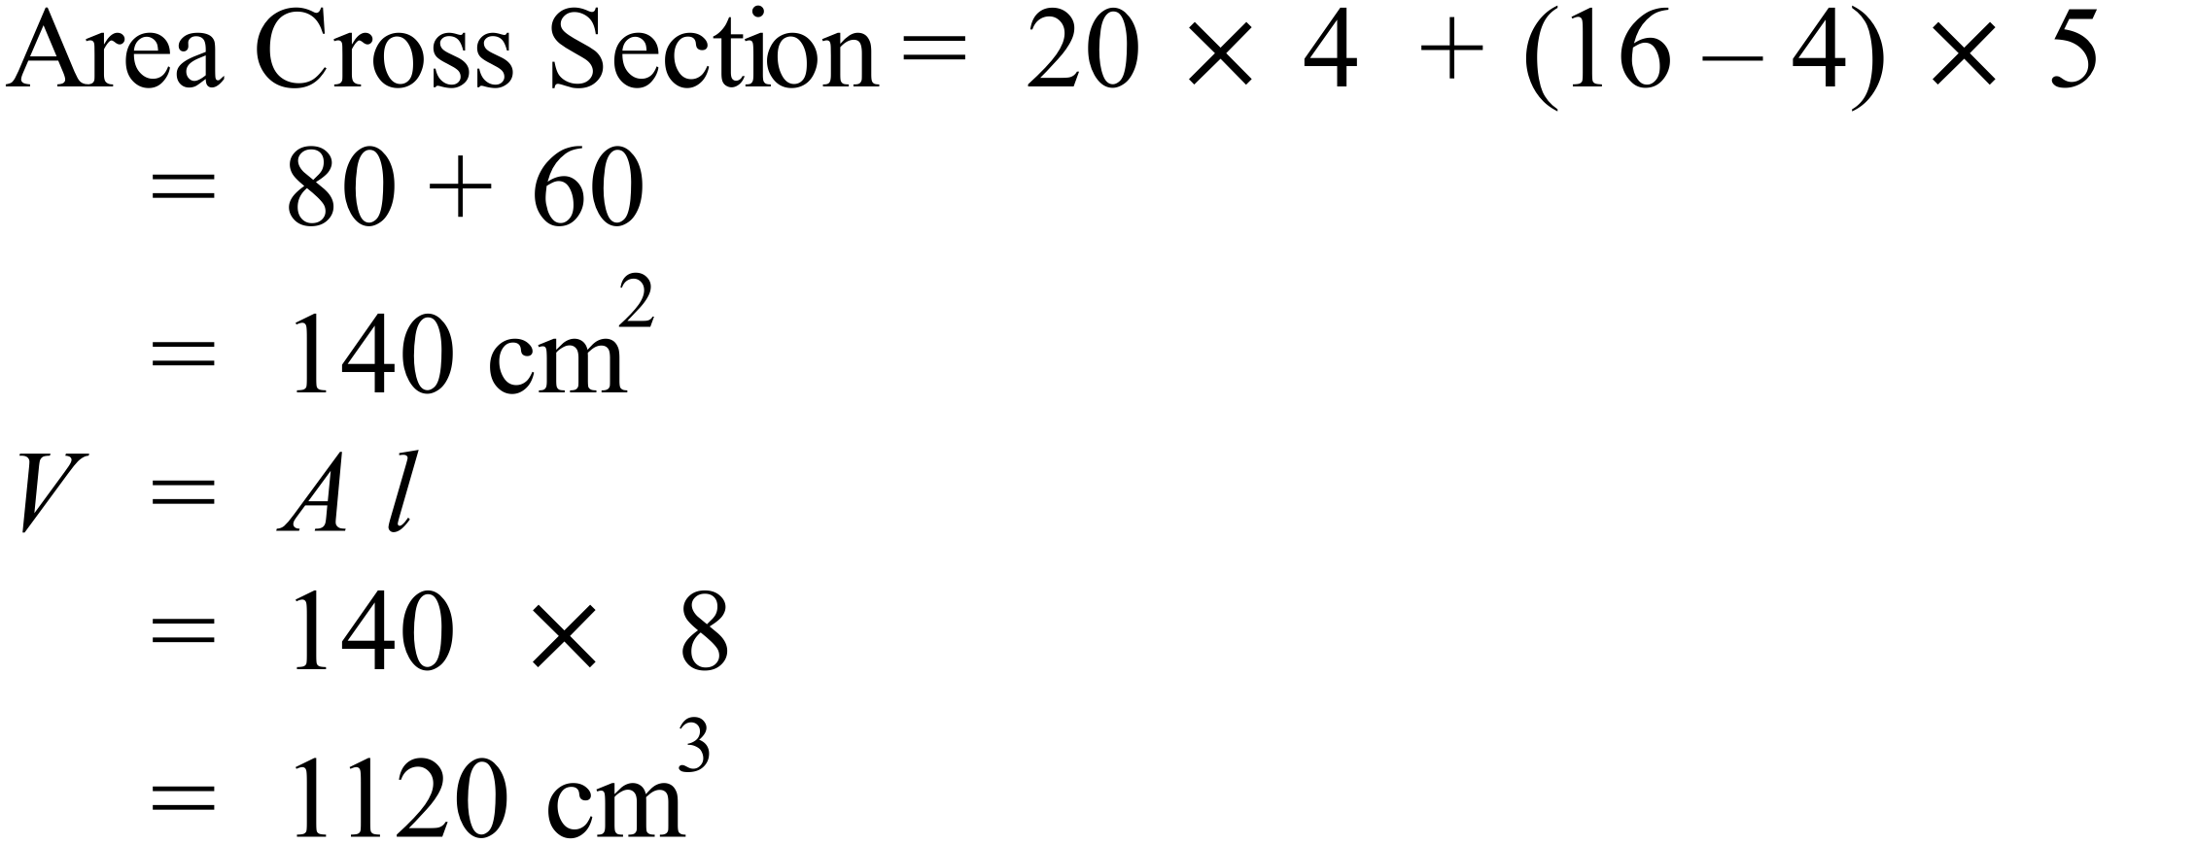 | A
 | 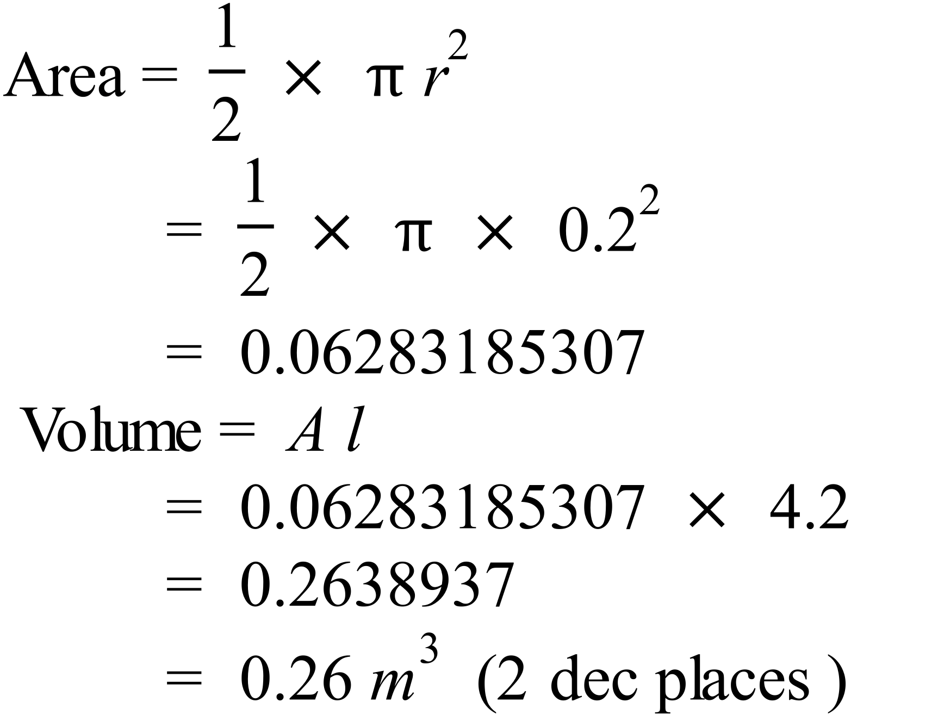 | B
 | 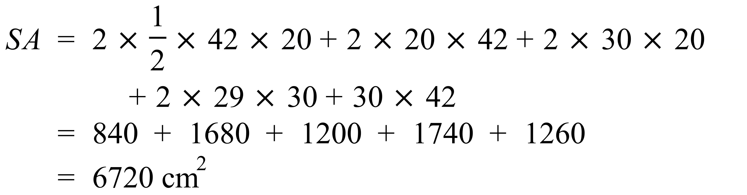 | A
 | 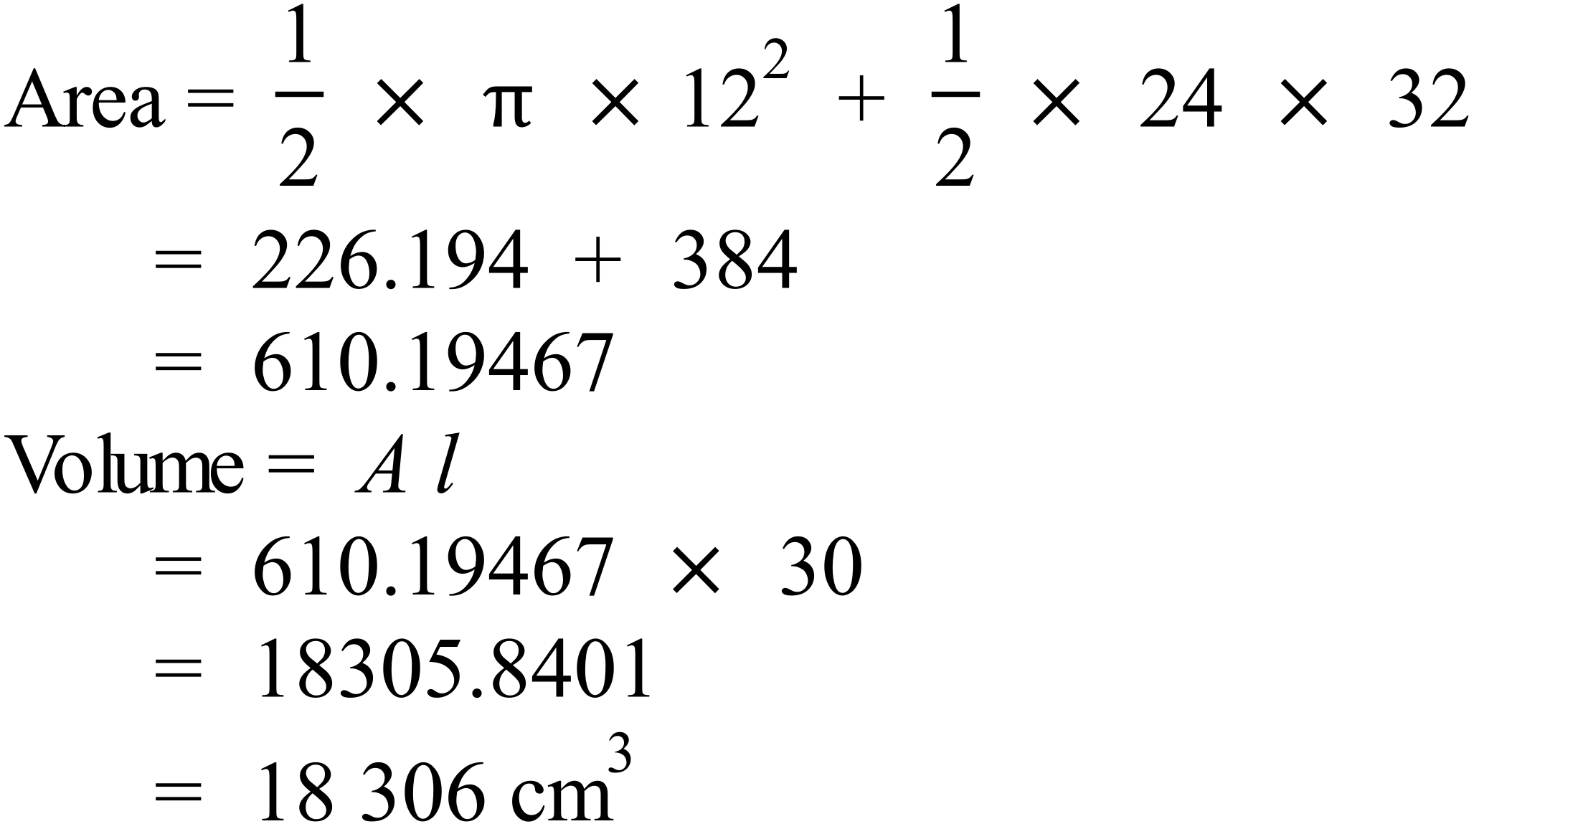 | C

School Name
Mathematics 2017
Multiple Choice Answer Sheet
Volume and SA of Prisms and Cylinders
Name _____________________________________________
Completely fill the response oval representing the most correct answer.
1. A B C D
2. A B C D
3. A B C D
4. A B C D
5. A B C D
6. A B C D
7. A B C D
8. A B C D
9. A B C D
10. A B C D
11. A B C D
12. A B C D
13. A B C D
14. A B C D
15. A B C D

